Introduction to Revit

Contents
1 Part I: A project-based introduction to parametric modelling via Revit 4
1.1 User Interface 5
1.2 Unit adjustment 6
1.3 Adding level 6
1.4 Adding grid lines 8
1.5 Creating foundation 12
1.6 Tile view 15
1.7 Adding column 16
1.8 Adding beams 23
1.9 Copying objects to another level 26
1.9.1 Hiding elements 26
1.9.2 Revealing hidden elements 30
1.10 Creating Wall 33
1.10.1 Aligning wall 35
1.11 Creating floor 36
1.12 Creating roof 39
1.13 Changing roof system 40
1.14 Creating door 41
1.15 Creating window 42
1.16 Creating stairs 42
1.16.1 Adding shaft opening 50
1.16.2 Editing shaft opening 53
1.17 Adding components 56
1.18 Generating an internal cam view 57
1.19 Adding annotations 59
1.19.1 Dimension line 59
1.19.2 Room tag 60
1.20 Creating drawing sheet 63
1.20.1 Enlarging information added 63
2 Part II: Creating Revit model based on AutoCAD drawing 68
2.1 Importing an AutoCAD drawing to Revit 68
2.1.1 AutoCAD prerequisite for Revit 68
2.1.2 Unifying the units in both software applications 68
2.1.3 Separate the drawings 68
2.1.4 Coordinating drawings 69
2.2 Importing to Revit 71
2.2.1 Setting up Revit workspace 71
2.2.2 Adjusting or Creating levels 73
2.2.3 Importing AutoCAD files 73
2.2.4 Hiding the AutoCAD drawing of a lower level 75
2.2.5 Drawing wall 77

Part I: A project-based introduction to parametric modelling via Revit
Please be advised that this informal guideline inspires you how to deal with some more practical Revit’s capabilities, only. You need the instructions given by your trainer to make your model. Therefore, follow along as your trainer instructs.

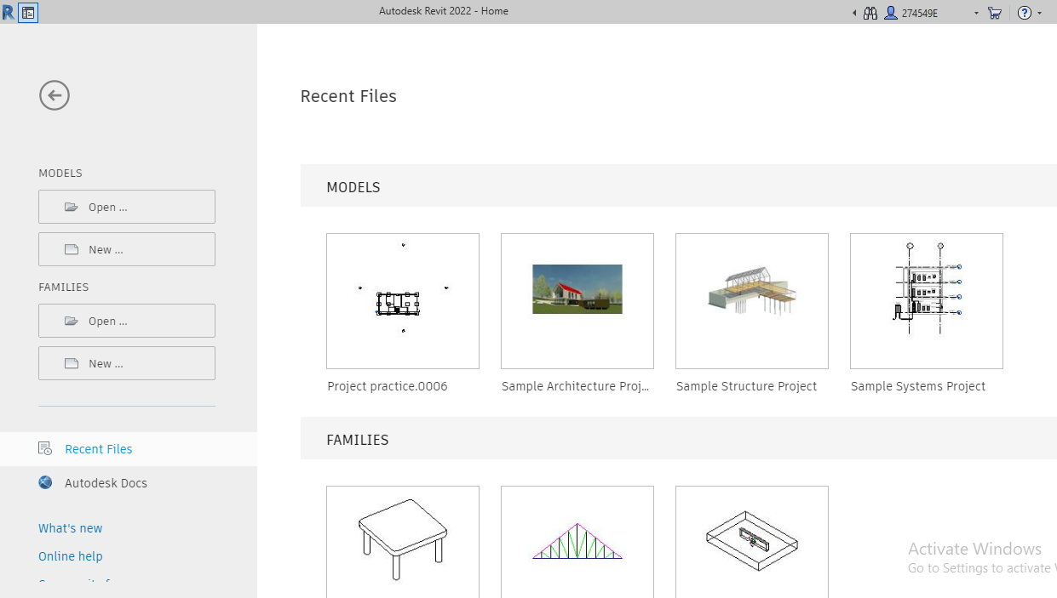

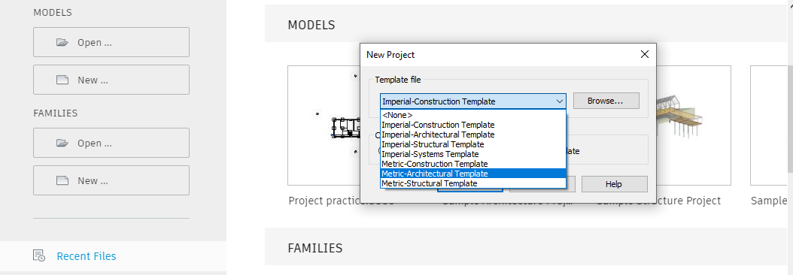

User Interface
Explore Revit user interface (tabs, ribbon, panels, commands, and tools). Go through the properties window including type parameter (under edit type) and instant parameters.

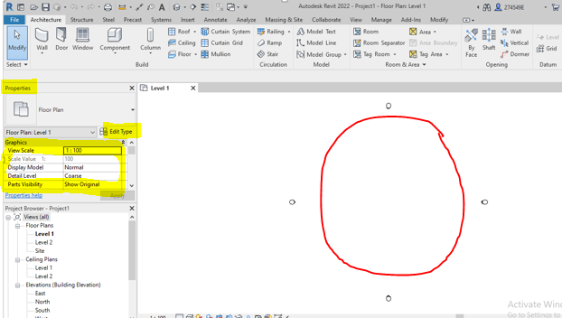

Unit adjustment
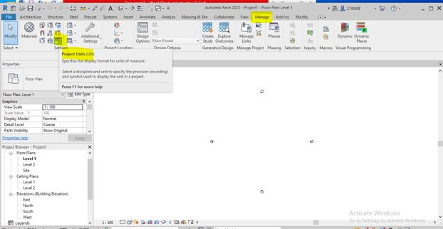
Set it to mm as below.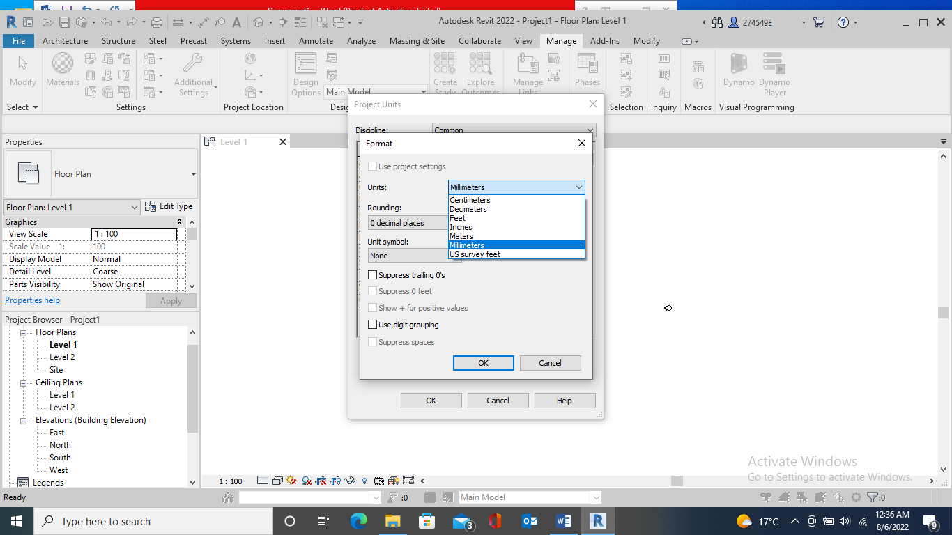

Adding level

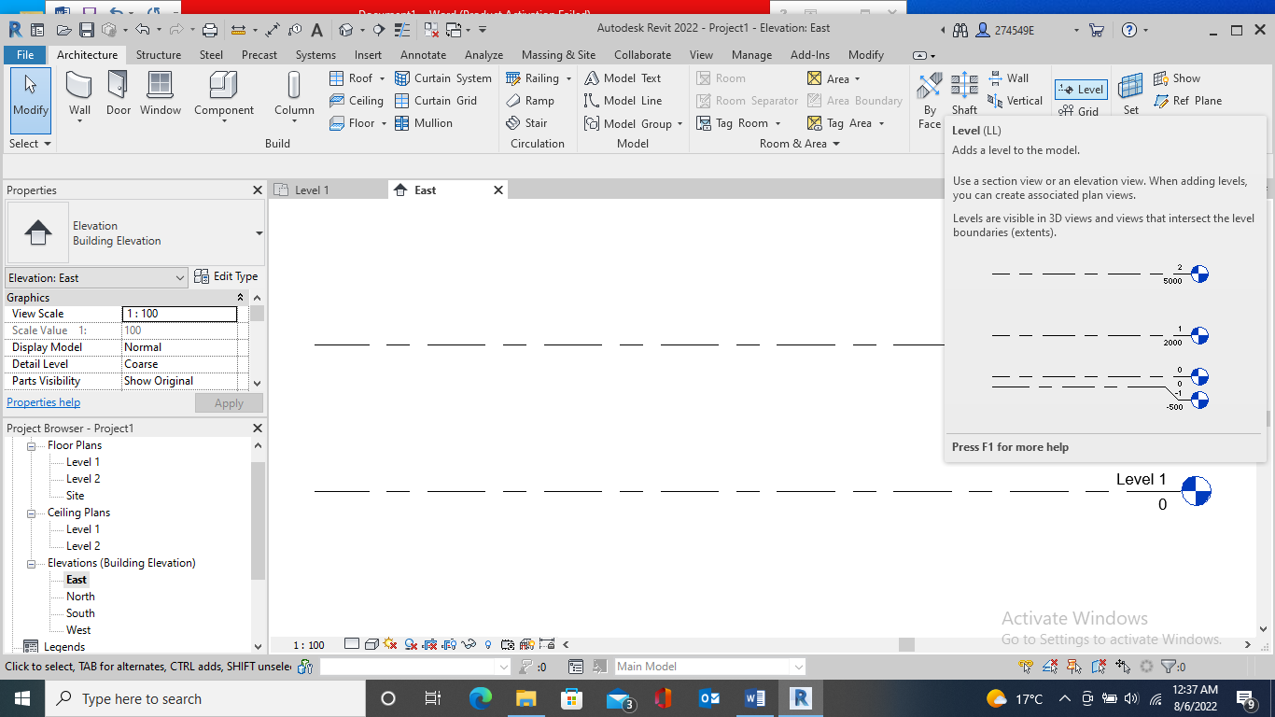
Apply Pick line tool, 800 mm Offset, create Foundation level and do level adjustments
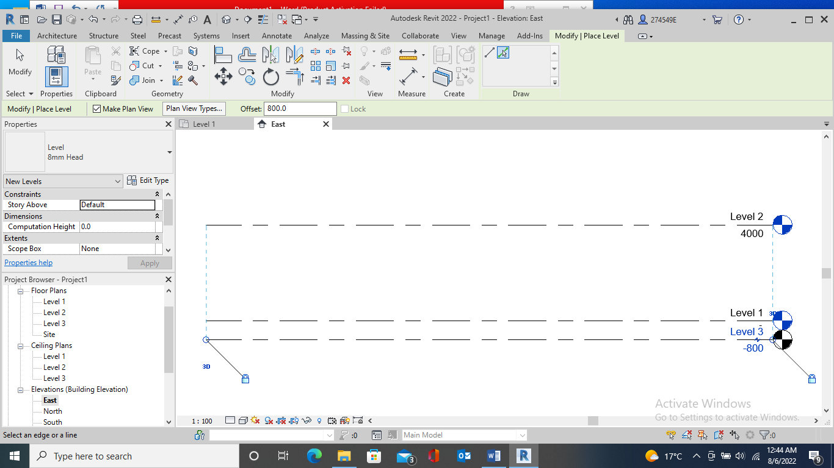

Use the offset or level command (click anywhere on the left& move to the right). Then, adjust the height. Let’s consider 3600& 7200 mm for the first and the second floor levels.

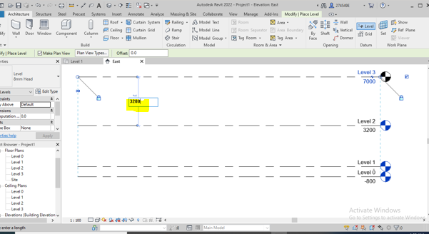

Adding grid lines
Go to level 0 under floor plans- under the Arch tab, use Grids in the Datum panel. There are 4 tools to draw the required grids as below. Let’s use straight line tool.
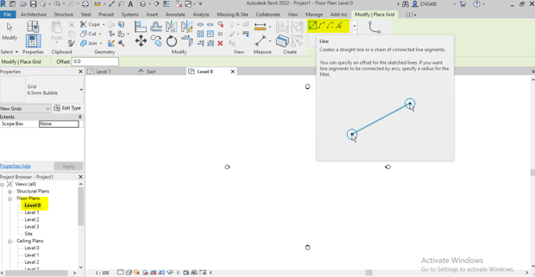

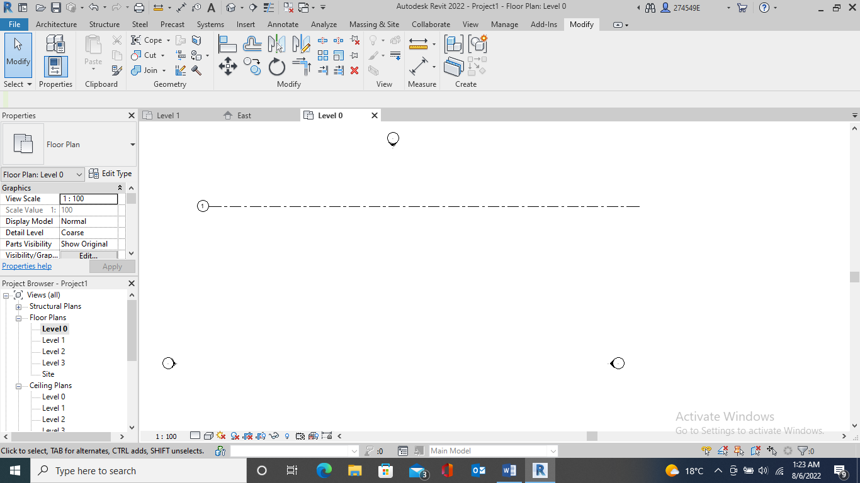
Now, switch to the pick line tool for creating multiple parallel grids based on the existing grid.

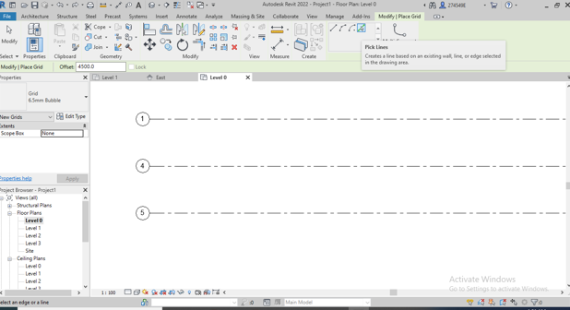
Using modify command and double-clicking in the globs, revise the grid’s name.
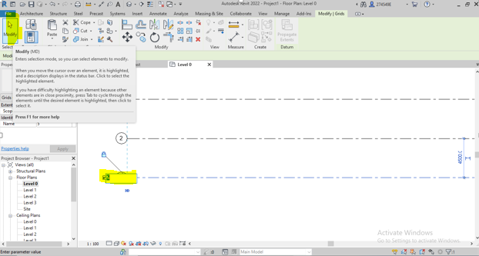
If not adjusted the existing names in proper order,

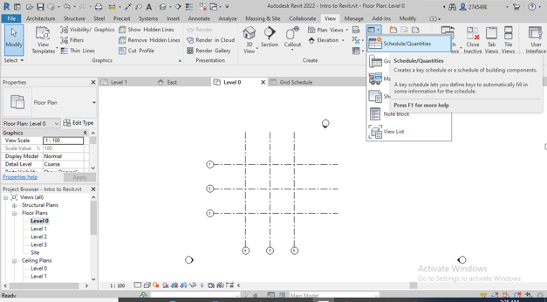
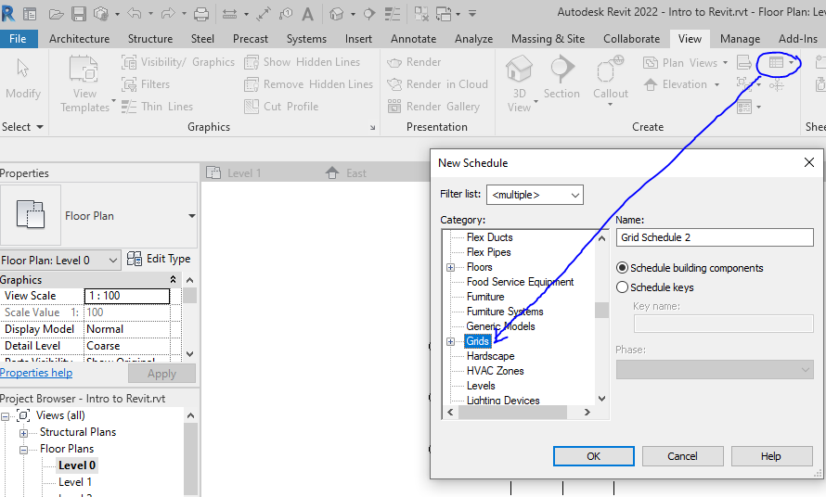
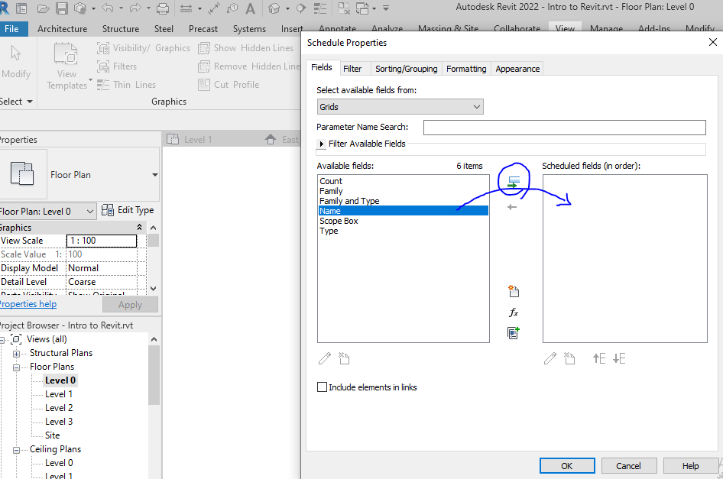

Delete the excessive name/s on the grid schedule and rename the grids, properly.

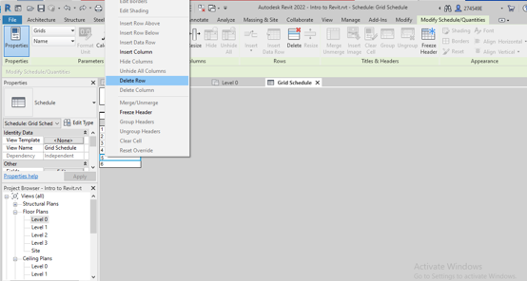

Creating foundation
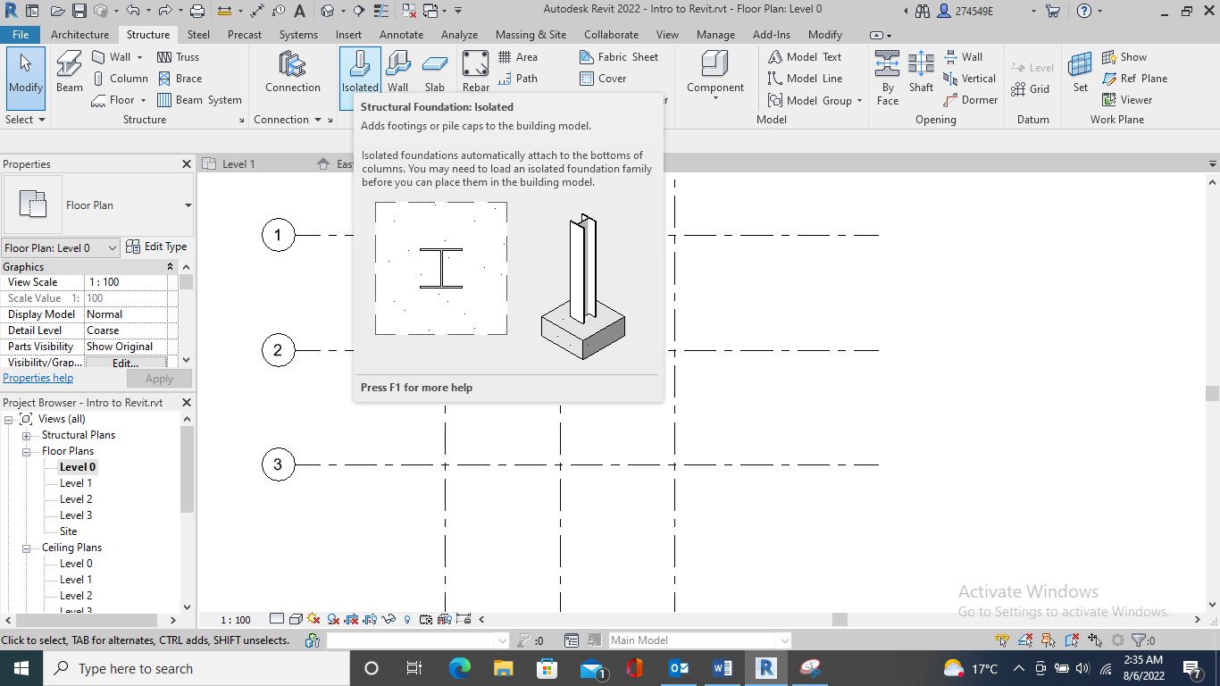
If no columns exist in the Revit library, then bring the required type from
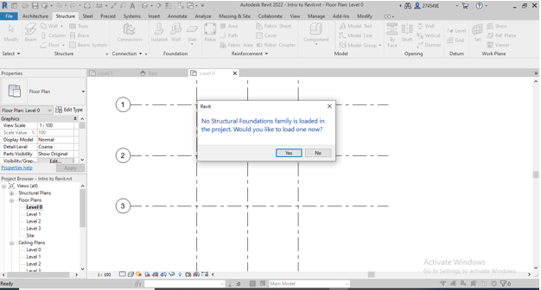

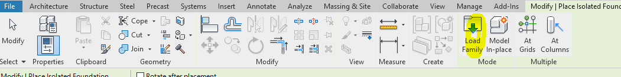

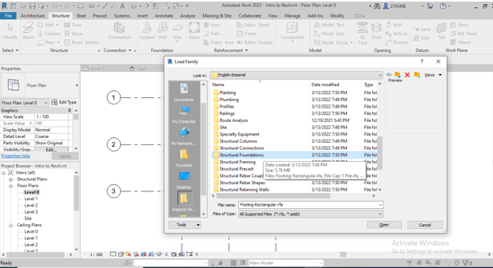

Adding the pads based on a specified dimensions.
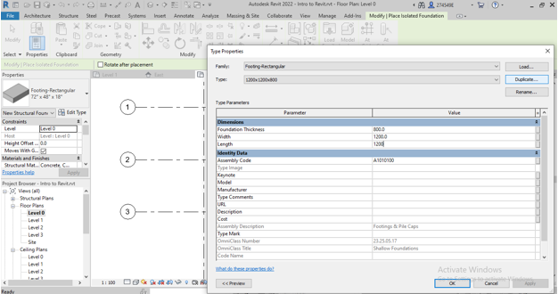

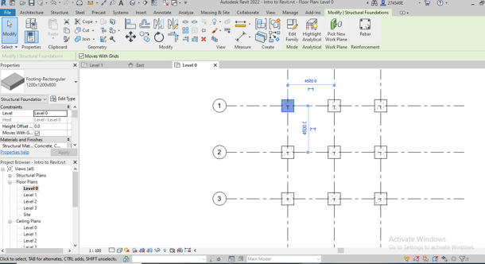
Not see the object? Then! Adjust the view range by typing V+R and set it to unlimited on the window pups up.
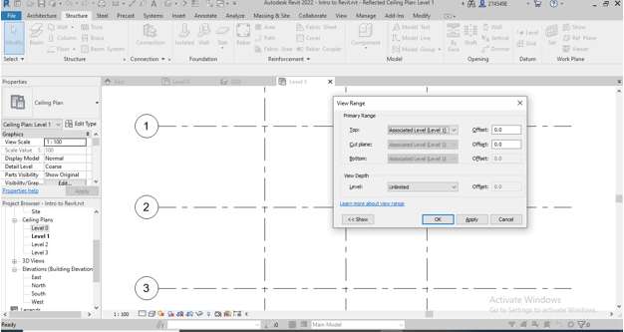

Tile view
Now, keep the views side by side (Tile viewing). Or W+T

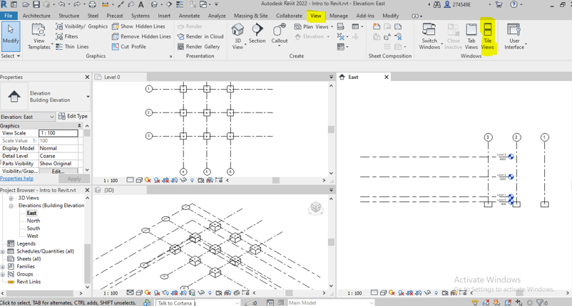

By selecting the grids, move the grid lines over grid 1 if you see a view the same as the east view above.

Adding column
If the required type of column is not loaded, load it from the load family icon under the insert tab.
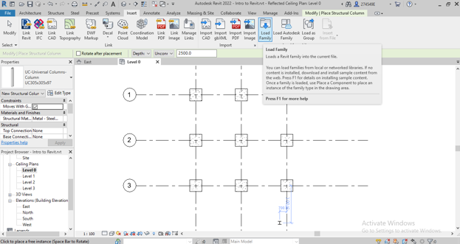

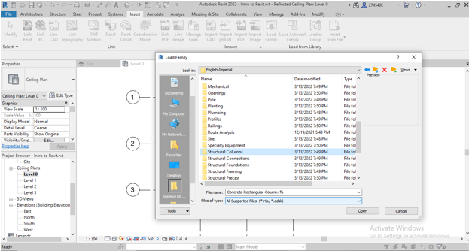
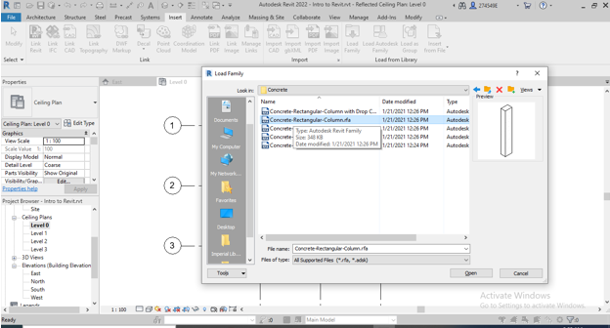

Stay on the floor plan, level1. Then, set the placement option. Depth or height? Level 1 or 2?

Select the columns as below and set the columns’ heights to level 3 using properties window.
Click on the intersection where the columns should be placed.

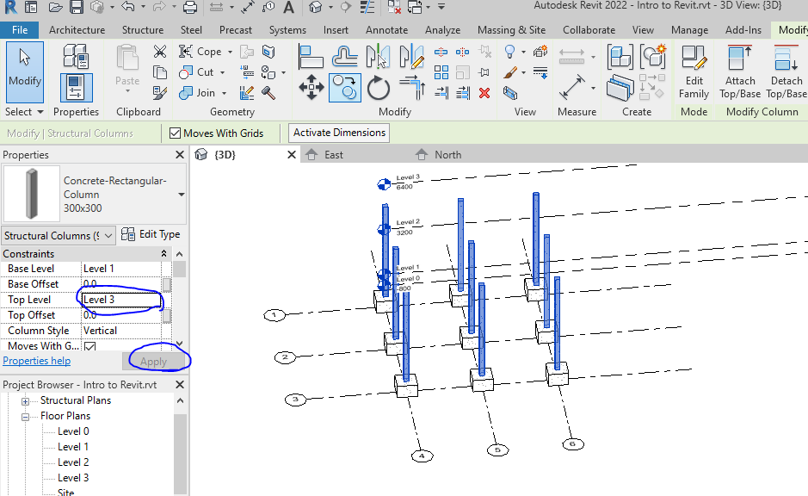

Alternatively,
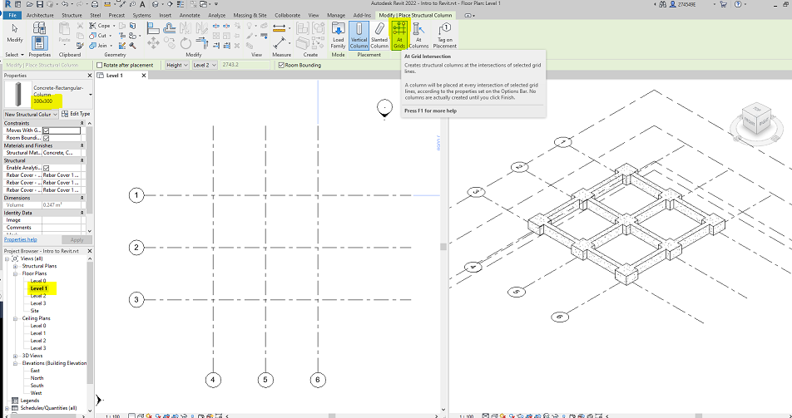
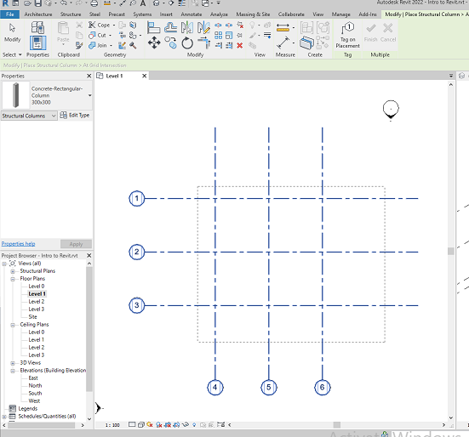
DO NOT forget to complete the command by using the green tick (Finish).
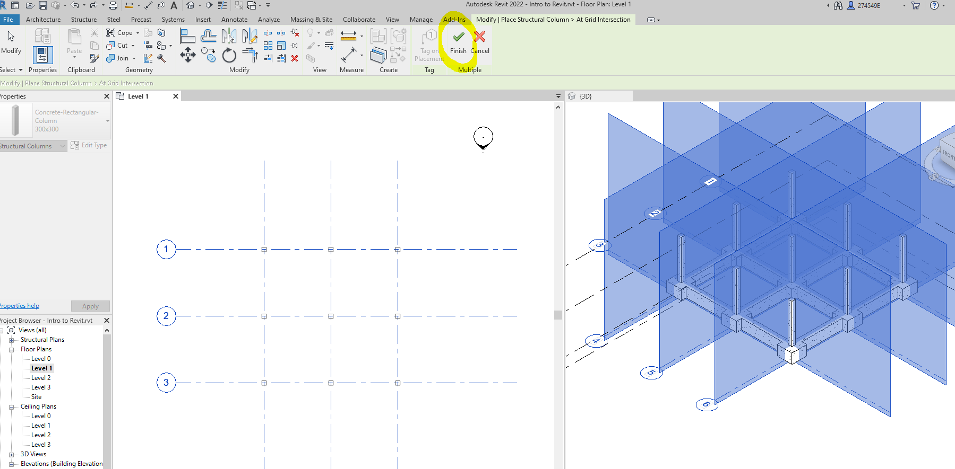

Stay at level 0 and draw the placement of the elements meets placement if they are placed as below.
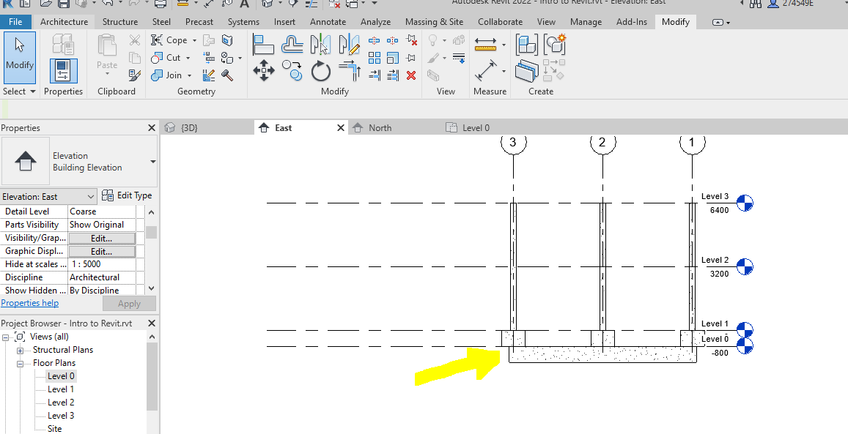

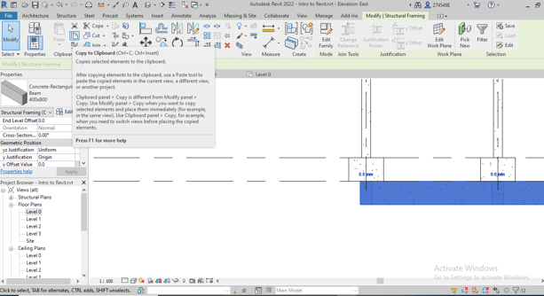

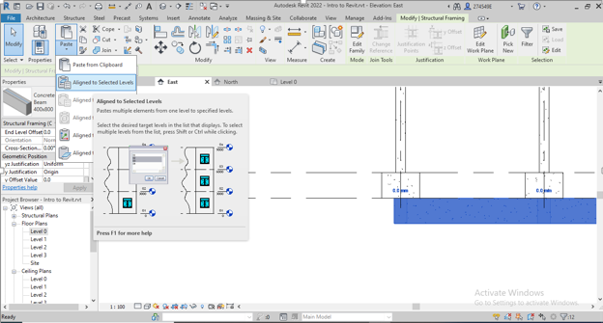

You should have got the model below w by now.
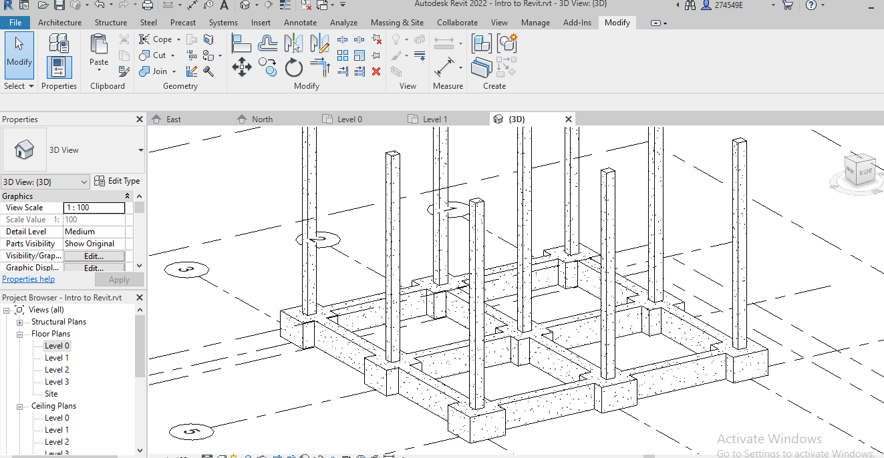

From a practical point of view, the traditional concrete structure is built up story by story. Then, correct the columns’ height. To so this end, select the elements and right-click (see below).
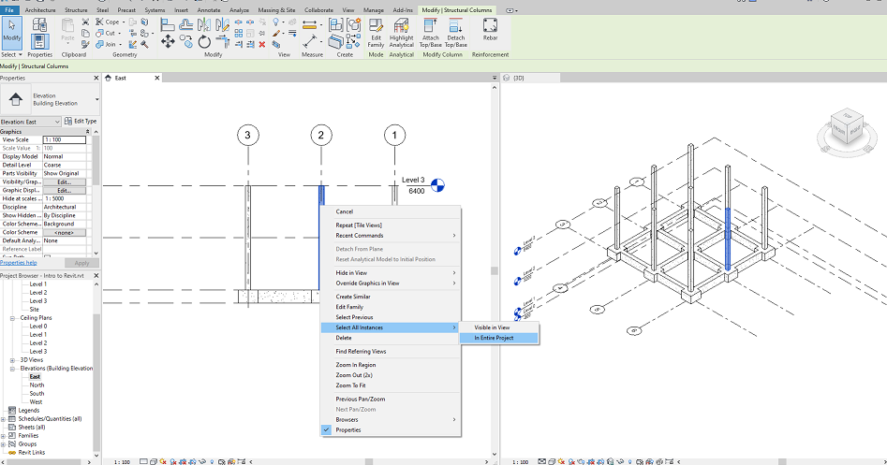
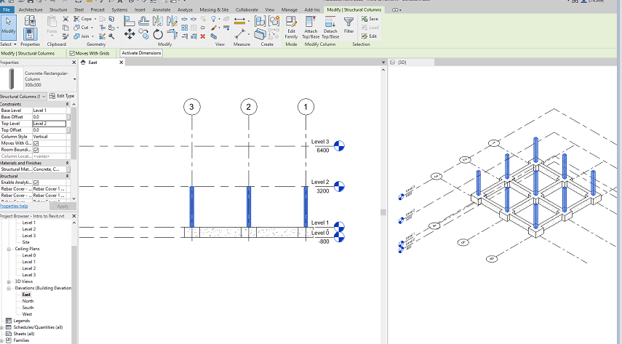

Adding beams
Create the required beam (300x400) in the properties window and place the beams at level 1.

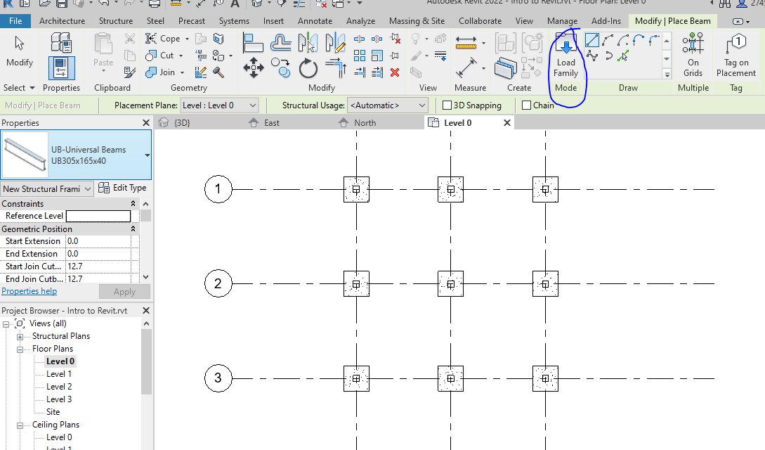
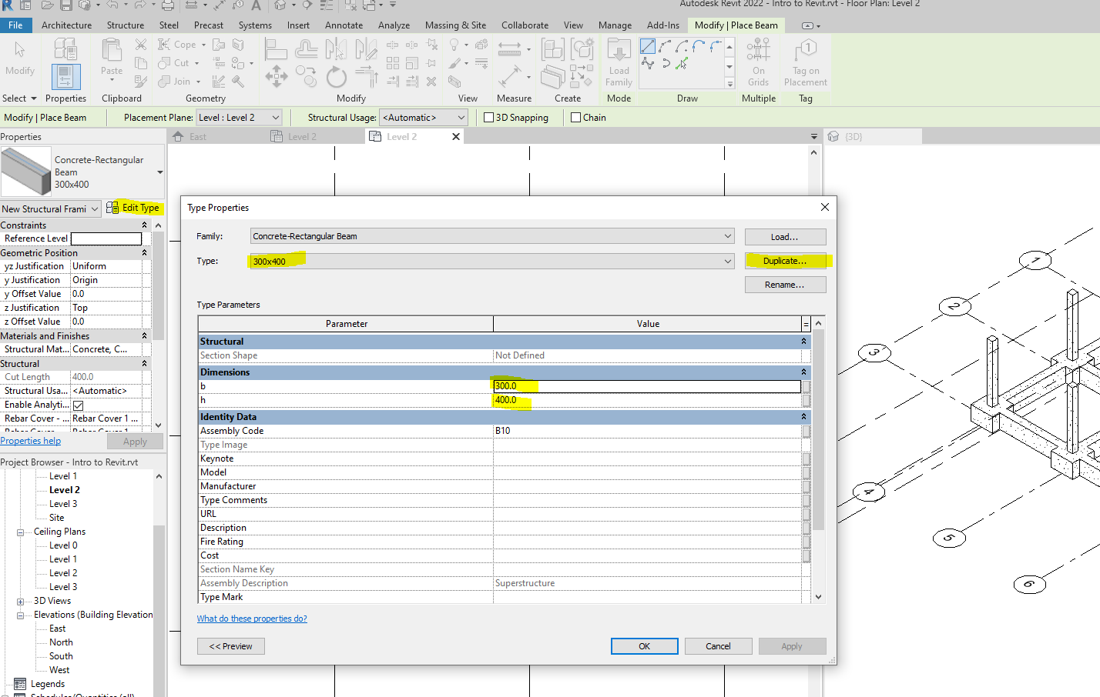

You can add the beams individually or using On Grids tool
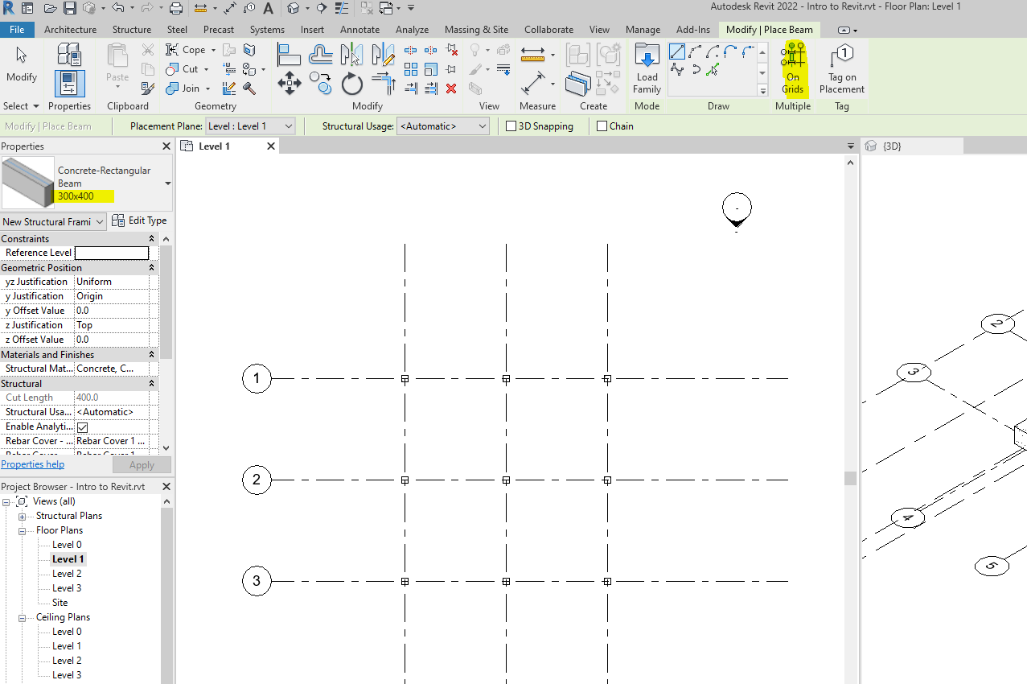

Stay at level 2, by using beam command and on Grids tool, place the beams and complete the action.
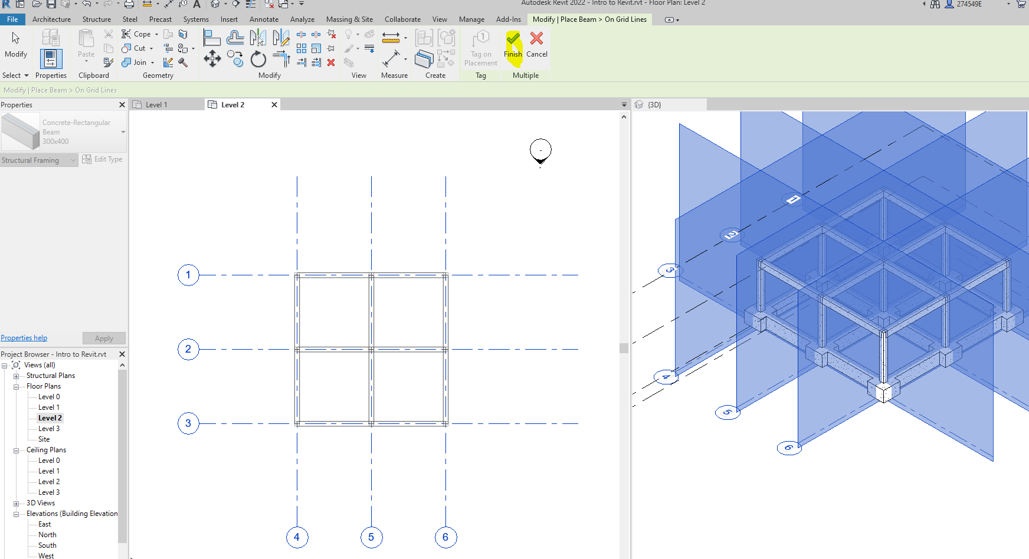

Copying objects to another level

Hiding elements
Place the same columns and beams for the second floor. Then, go to an elevation view, hide the grids
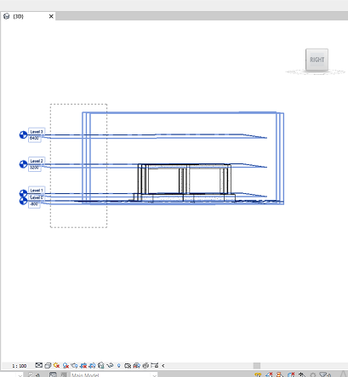
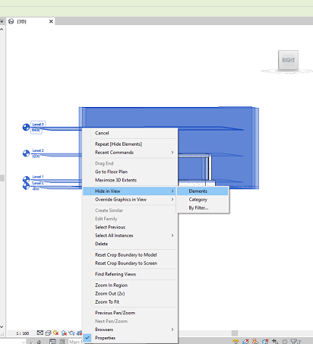
Now, select the structure
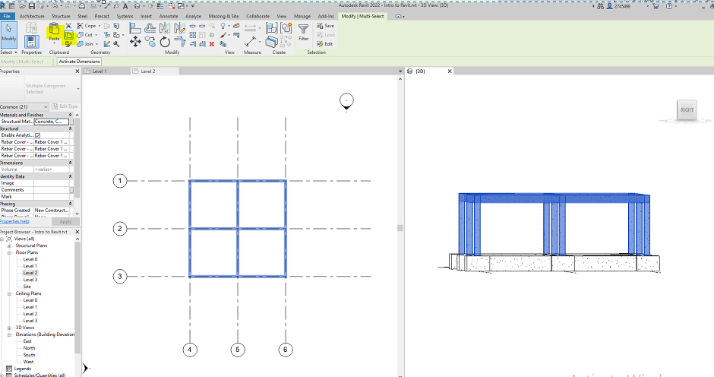
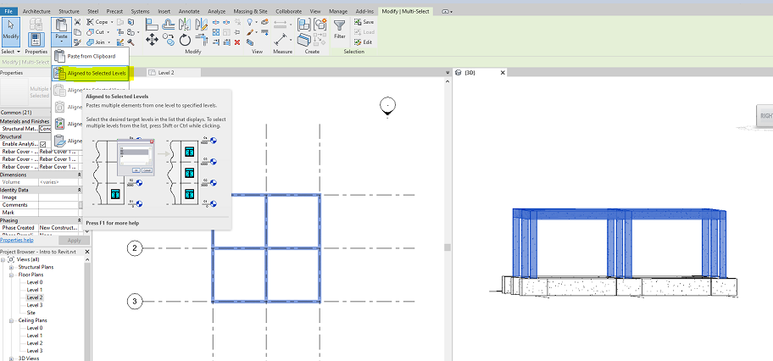
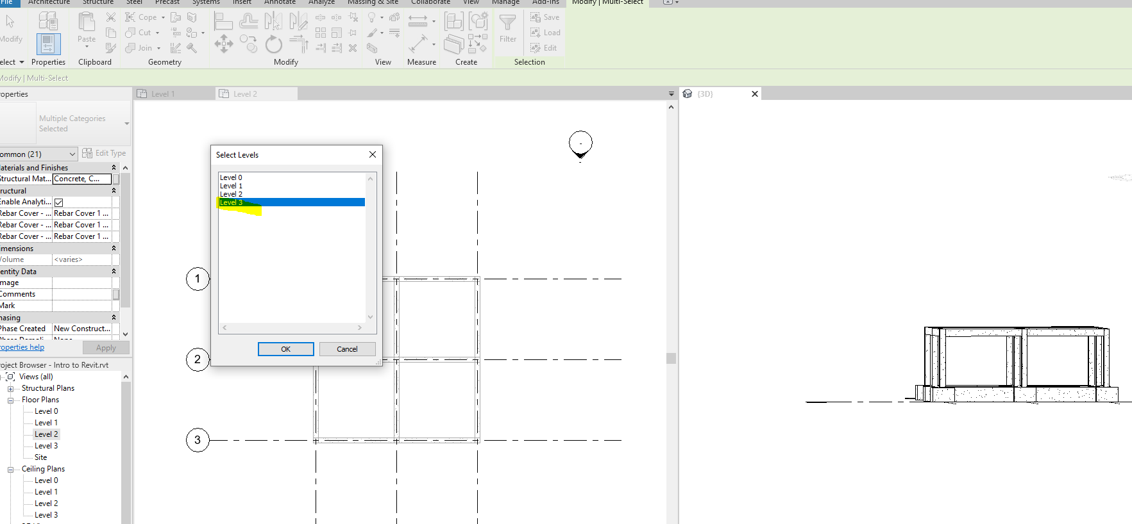
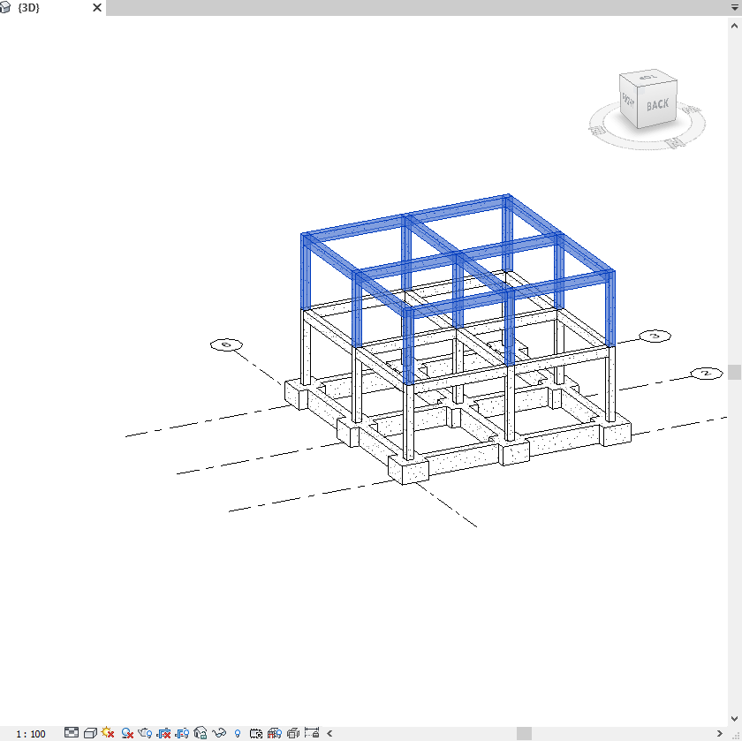

Revealing hidden elements
Now, get the hidden level and grid lines back.
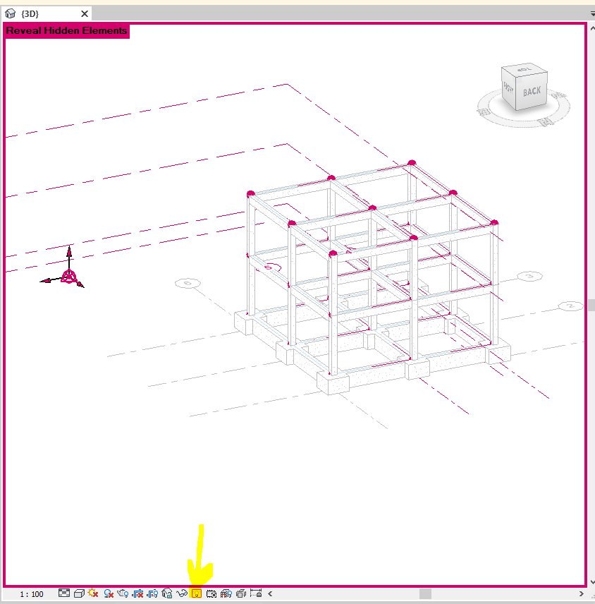
Select one of the hidden elements and follow below.
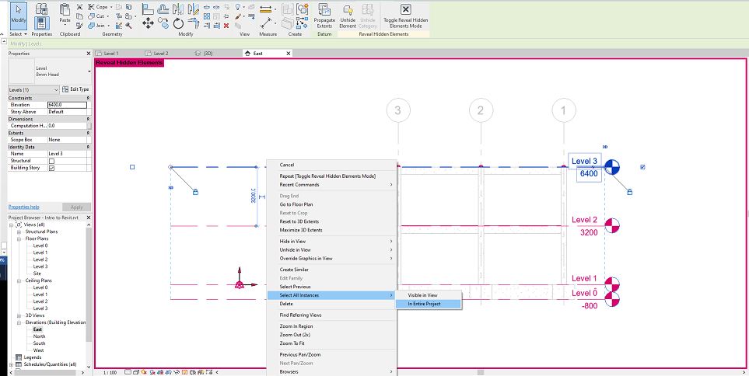
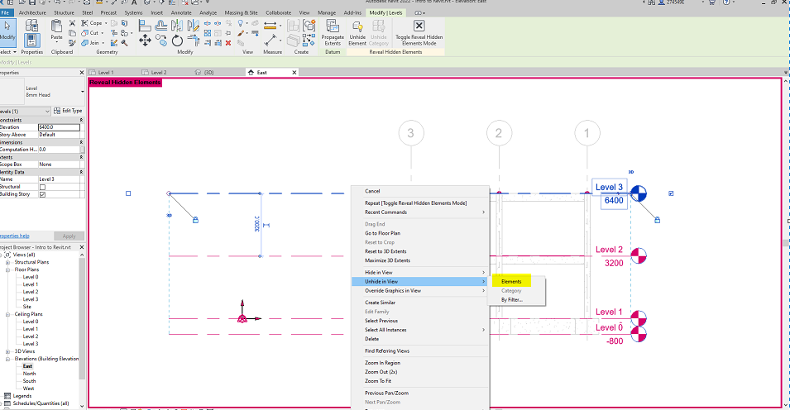
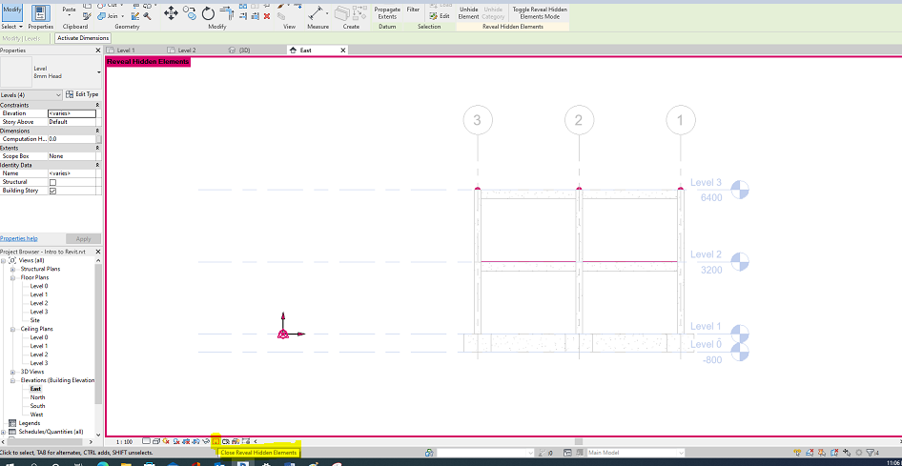

Creating Wall
Stay on the ground floor view. Use basic wall-200 mm create external walls, only.
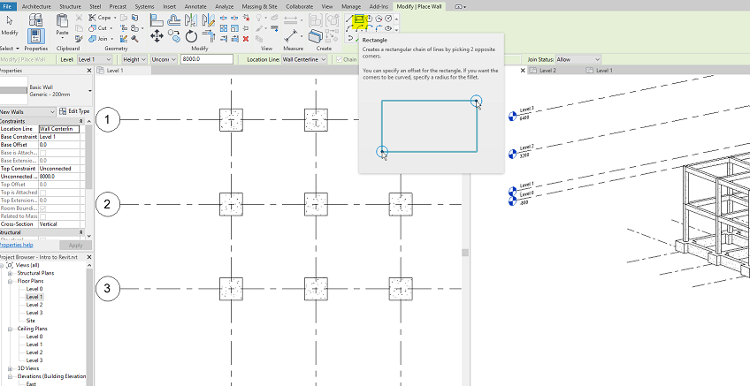

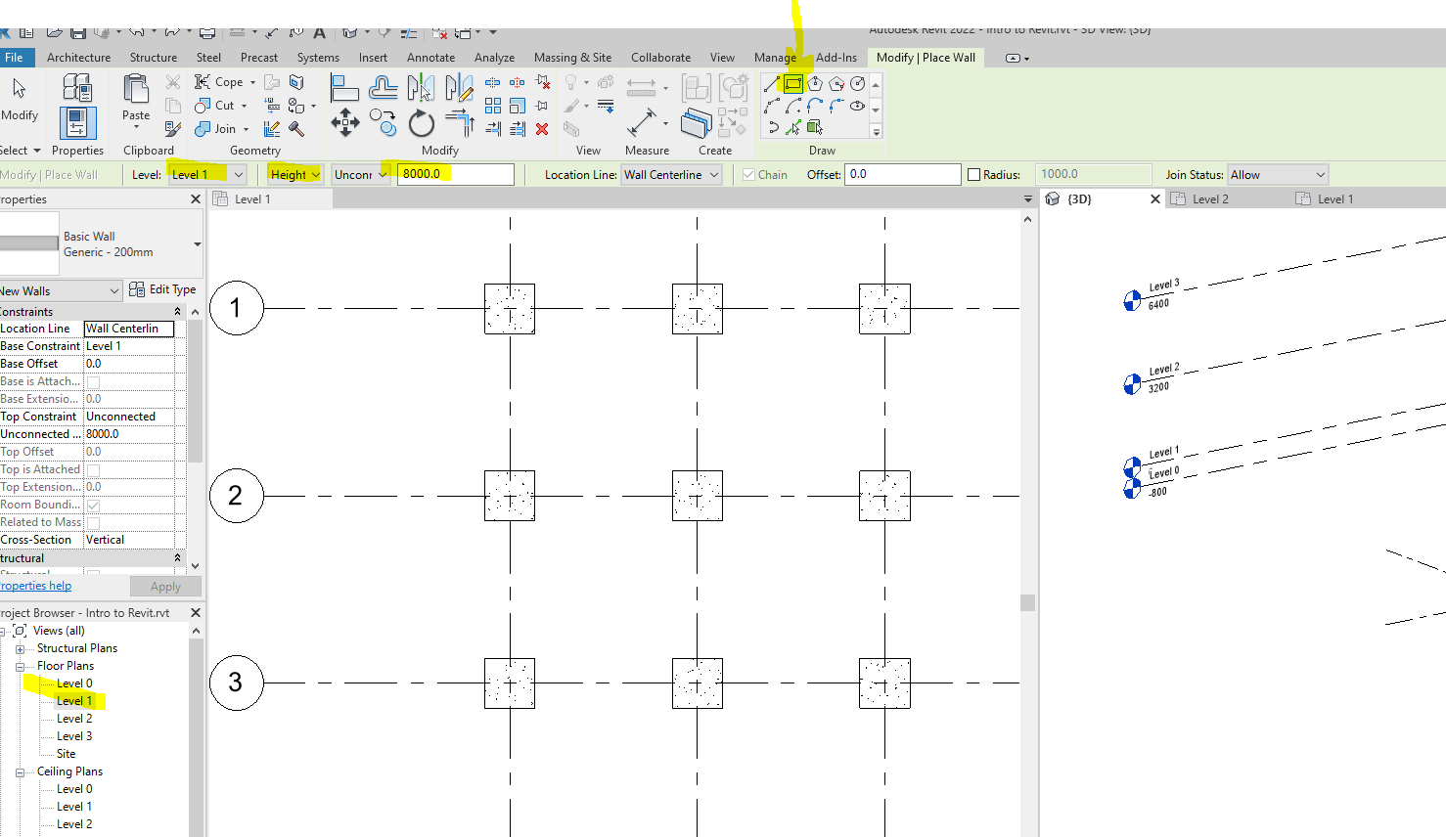

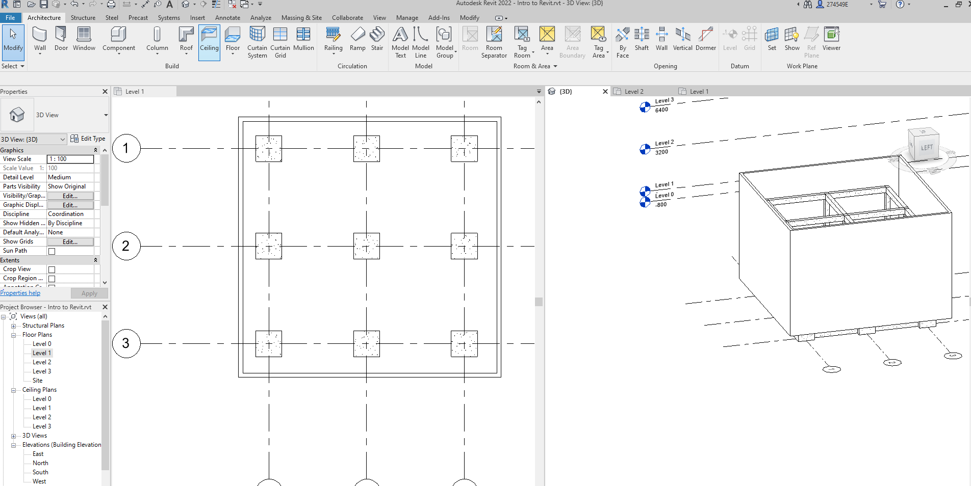

Aligning wall
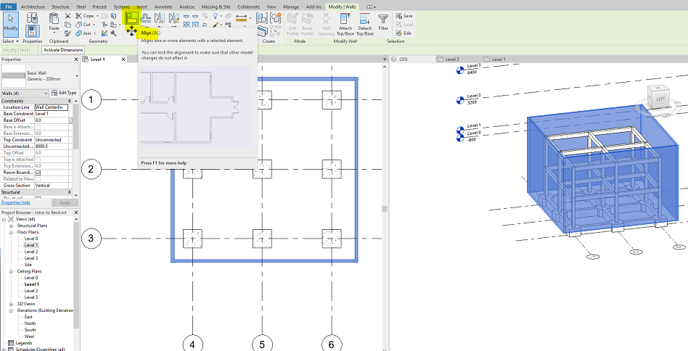
After activating the command, select the grid and then move/align the object & lock it. Repeat the process for the other sides.
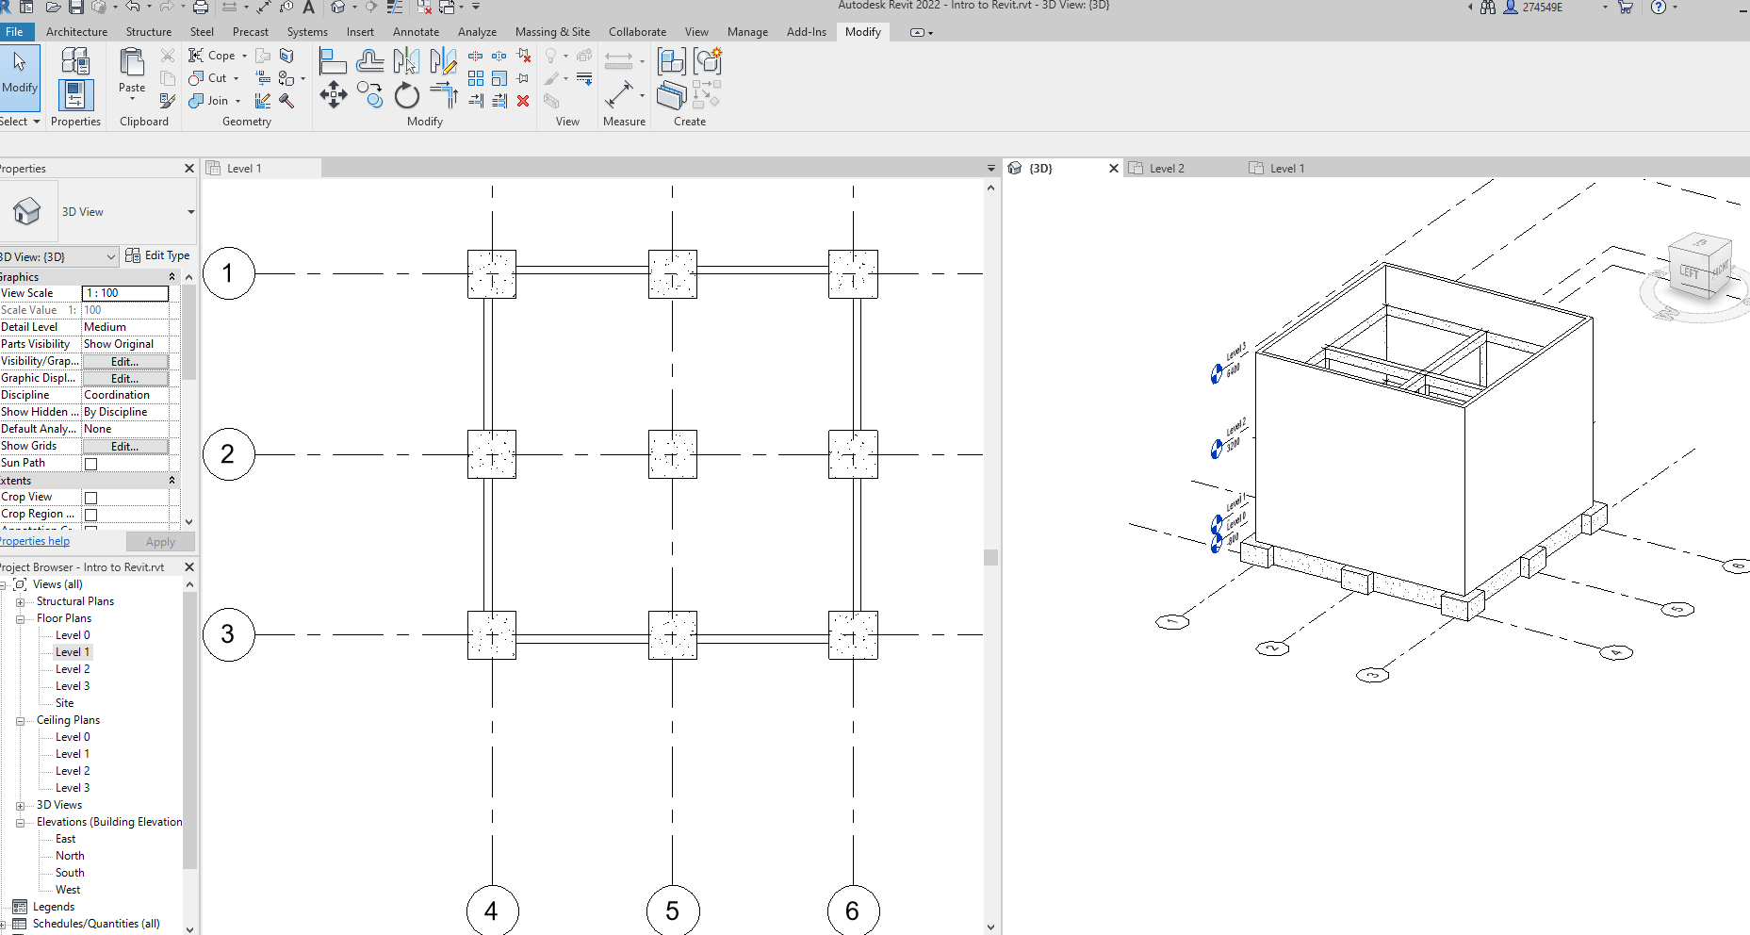

See the parameters under Edit.
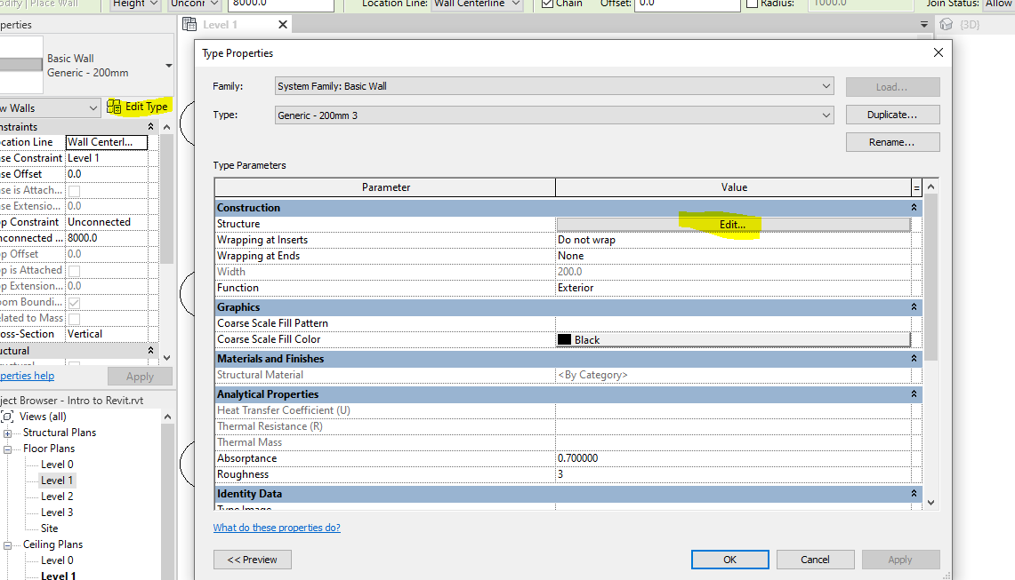

Creating floor
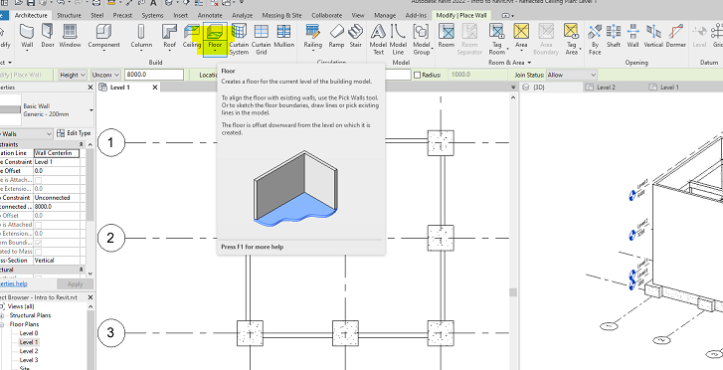

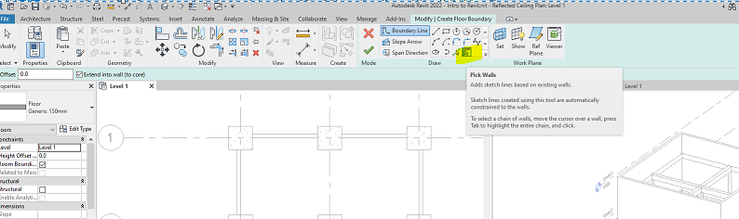
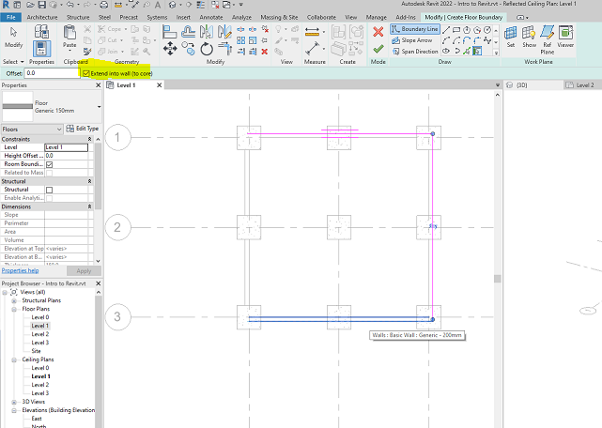

Complete the action by pressing the green tick finish.
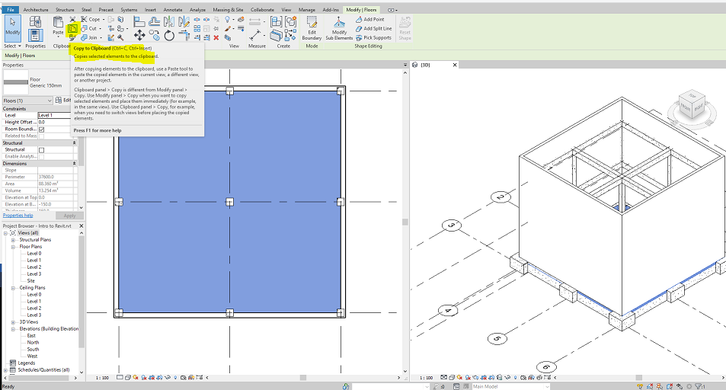

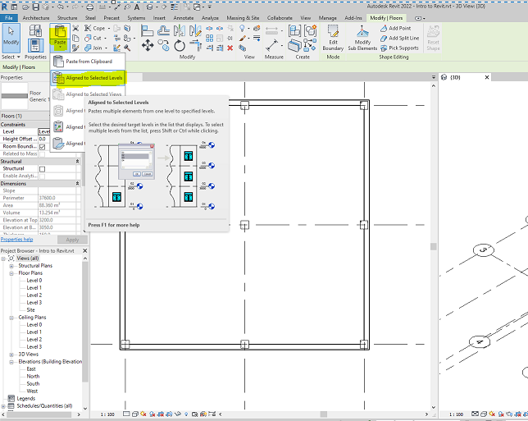

Creating roof
To add roof, go to the related level and see below.
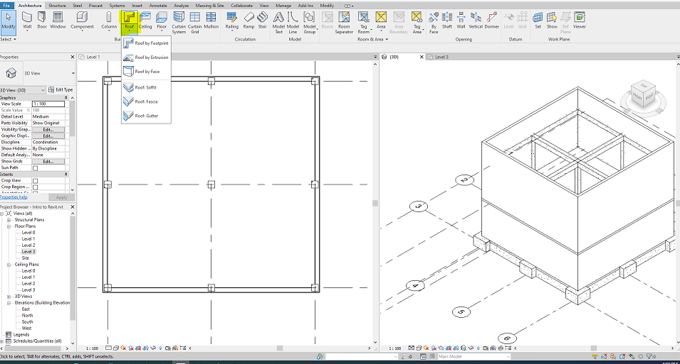

Select the roof type, tick the box of defines slope, determine overhang, and use the pick walls. Hover over the wall and click when you see the dash line beyond the walls.
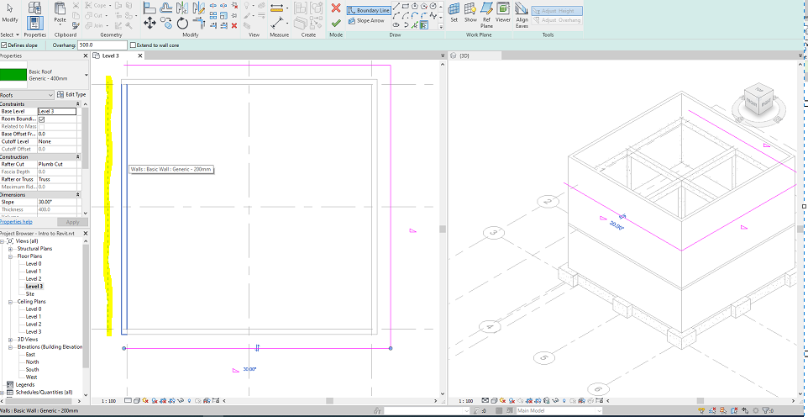
DO NOT FORGET TO COMPLETE THE ACTION BY PRESSING THE GREEN TICK.
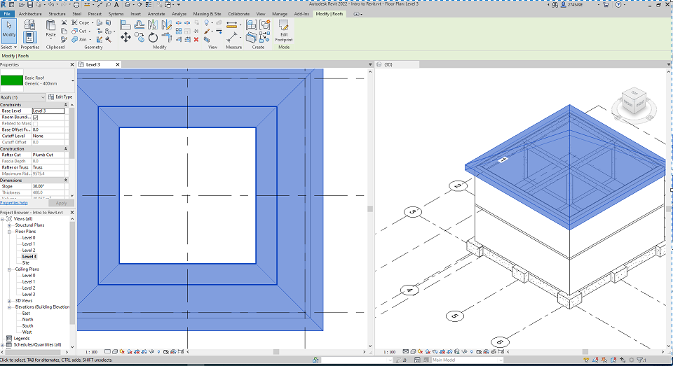

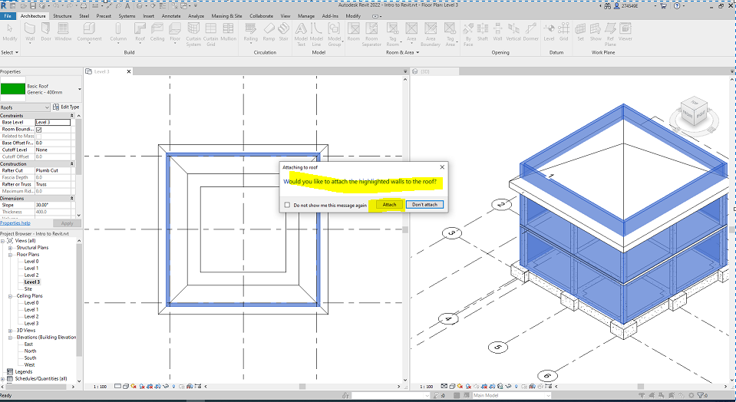

Changing roof system
Change the gable roof to a hip roof. To do so, select the roof→ Edith Footprint → select the edges to remove their slop followed by unticking Define slope and pressing the green tick.
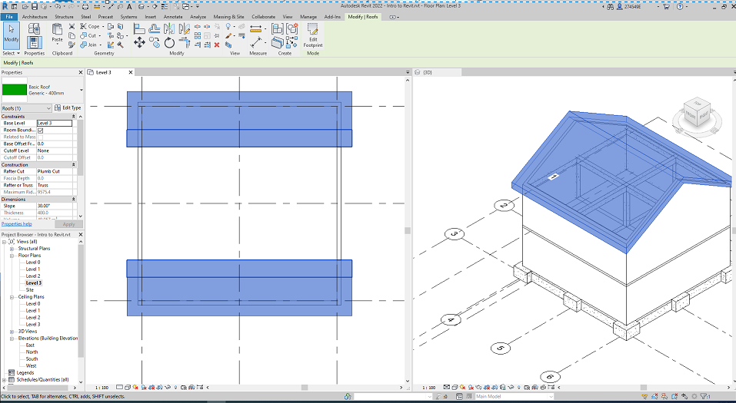

Creating door
Under the architecture tab, select the door type or bring the type from Load Family.
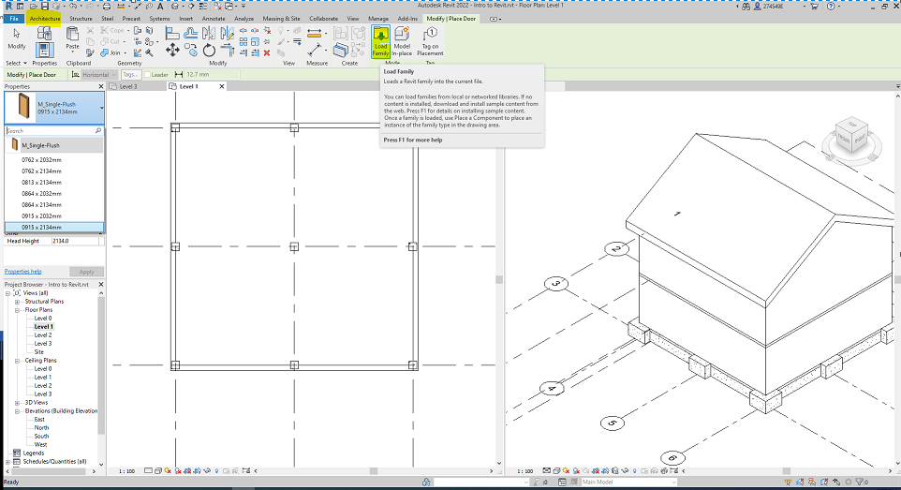
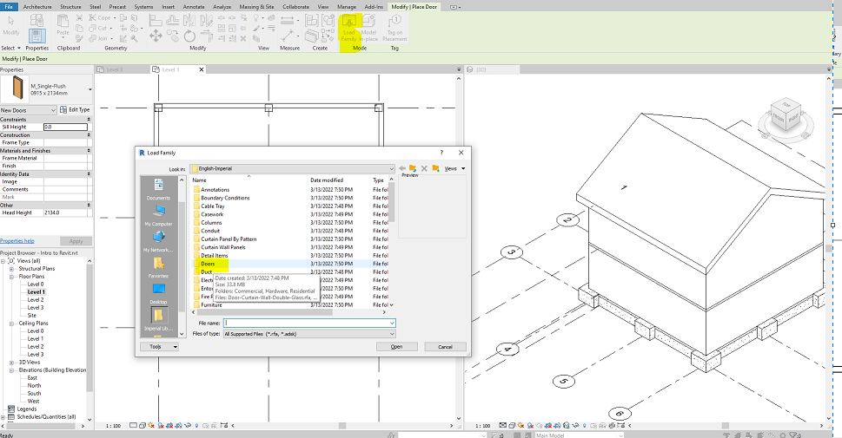
Place the door by clicking at the location.

Creating window
Add window by selecting the window tool and add from load family if need be. (The same process as the door creation)

Creating stairs
To create stairs, outline the stair by using the ref plane under the Arch tab, randomly.
To see the outline, better to hide the grids, first.
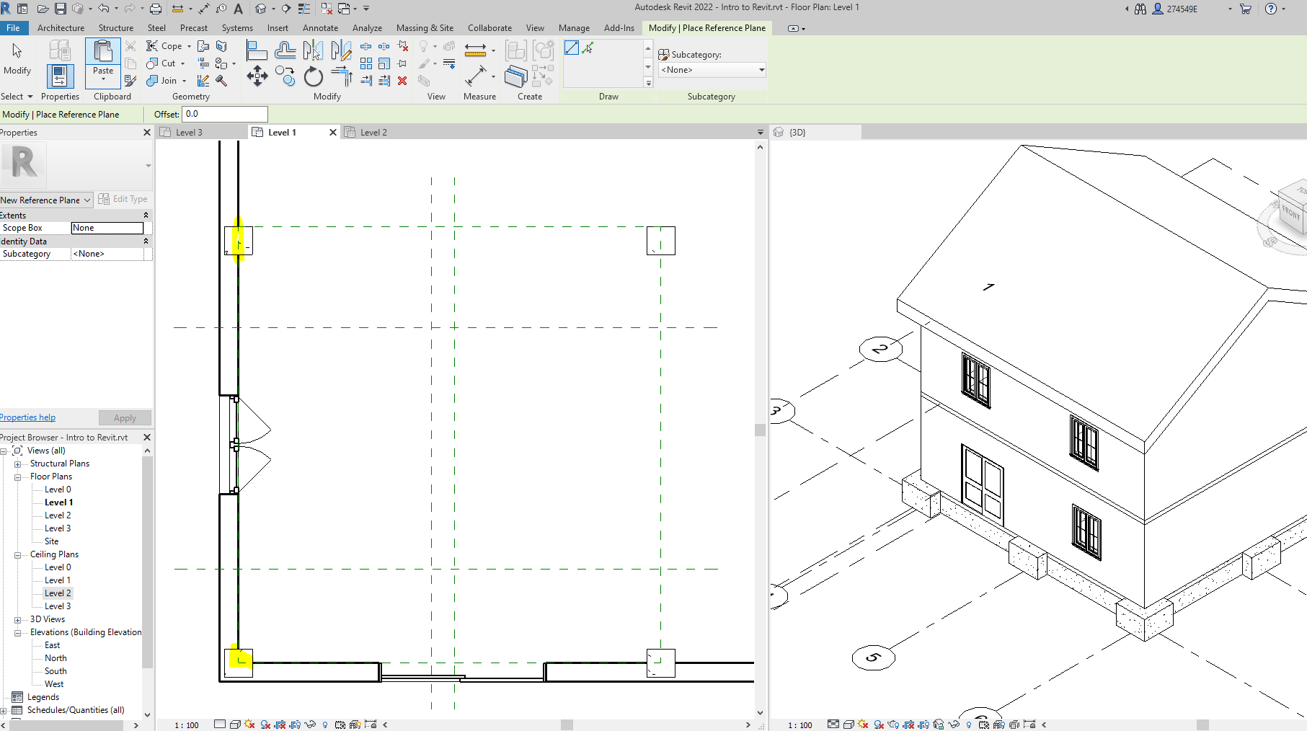
Then, measure dimensions on the reference plane. Then, see the dimensions.
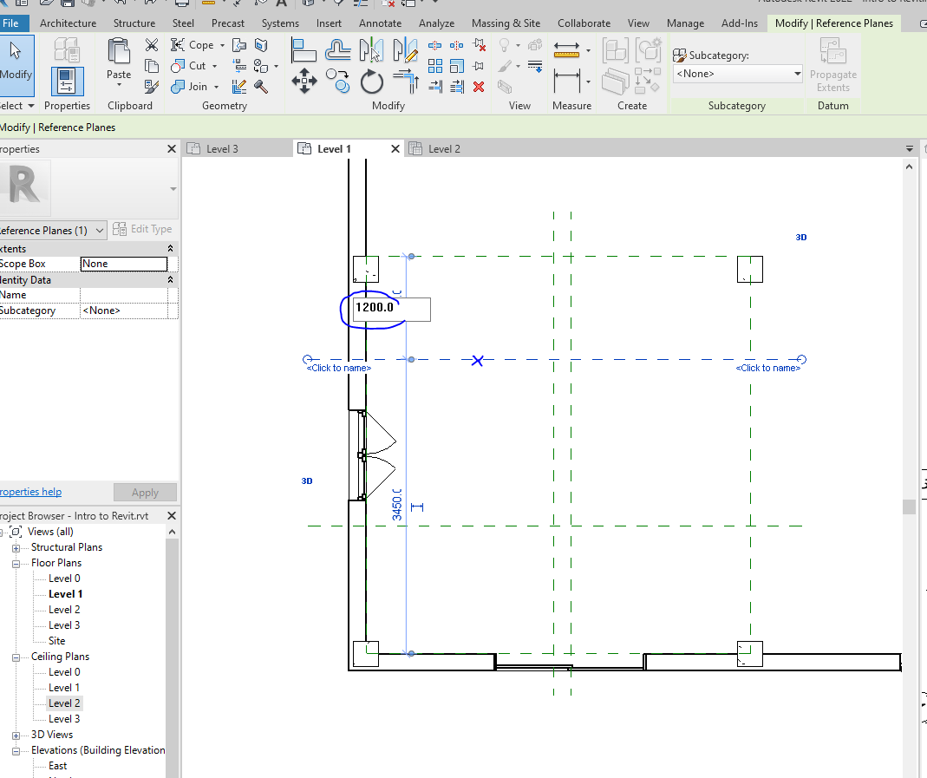
Now, update them to our desired dimensions.
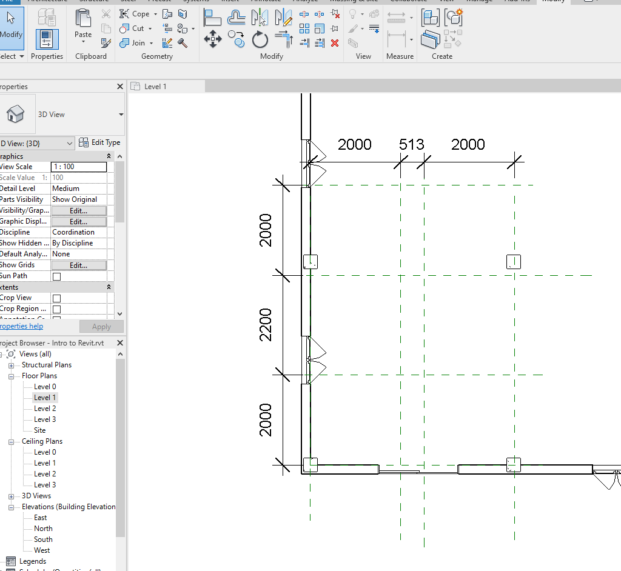

Under the Arch tab,
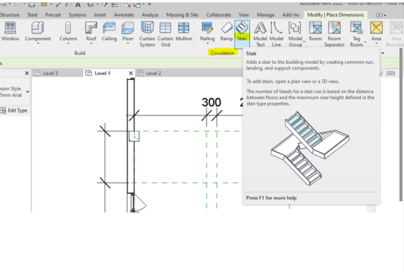

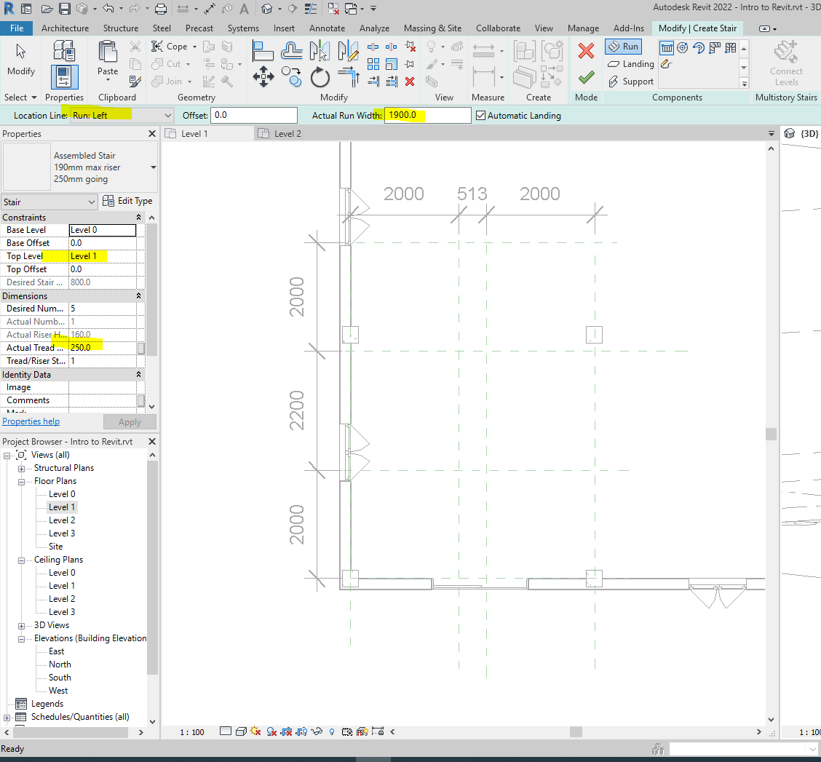

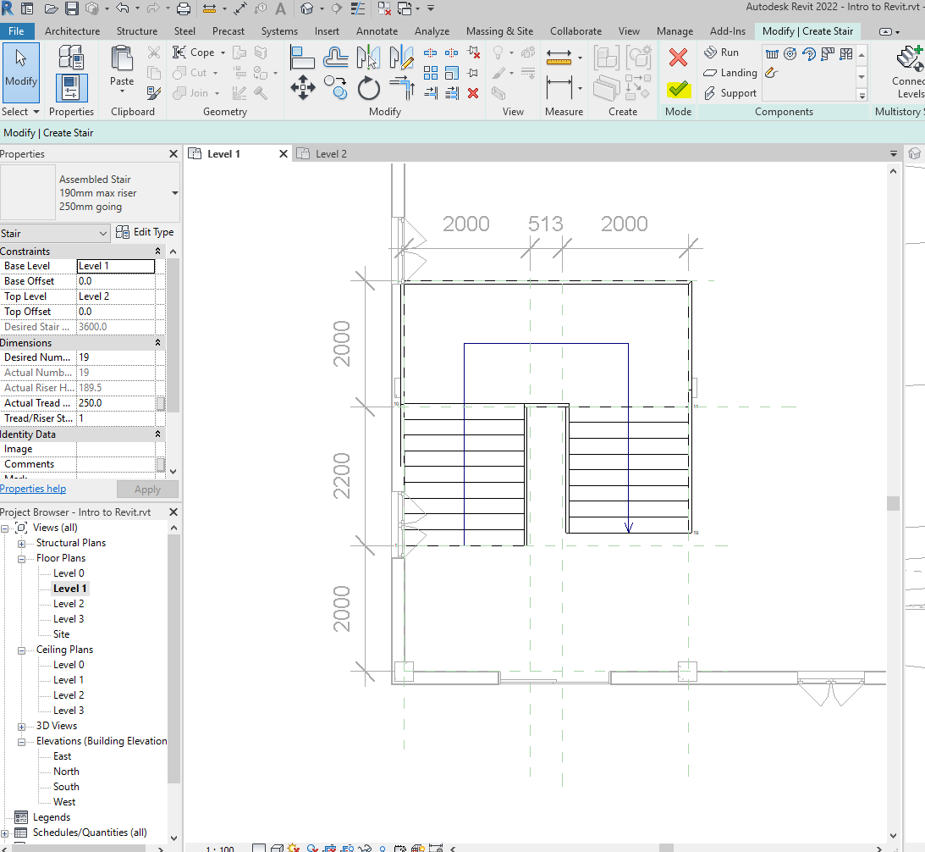
Check out stairs in 3D by hiding the element in front.
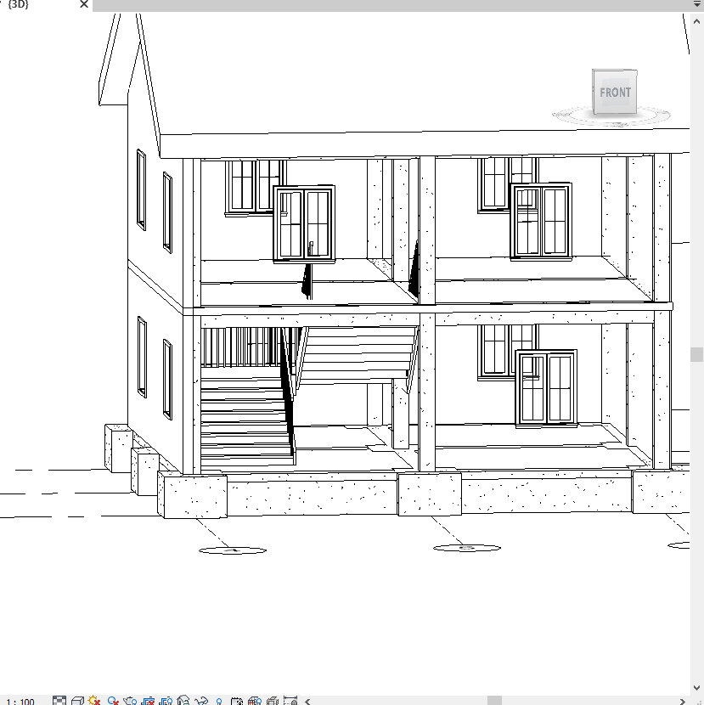

Use the section box to see the unopened shaft.

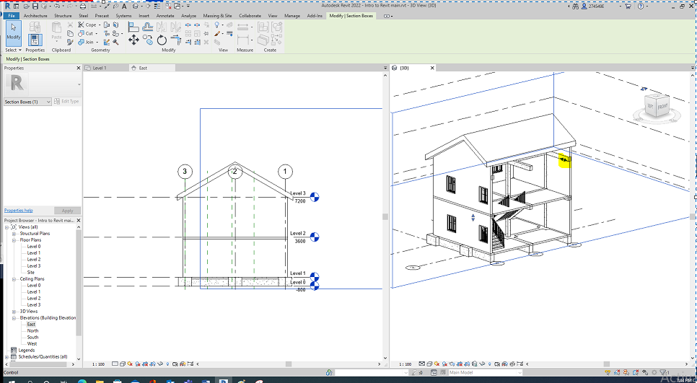

Adding shaft opening
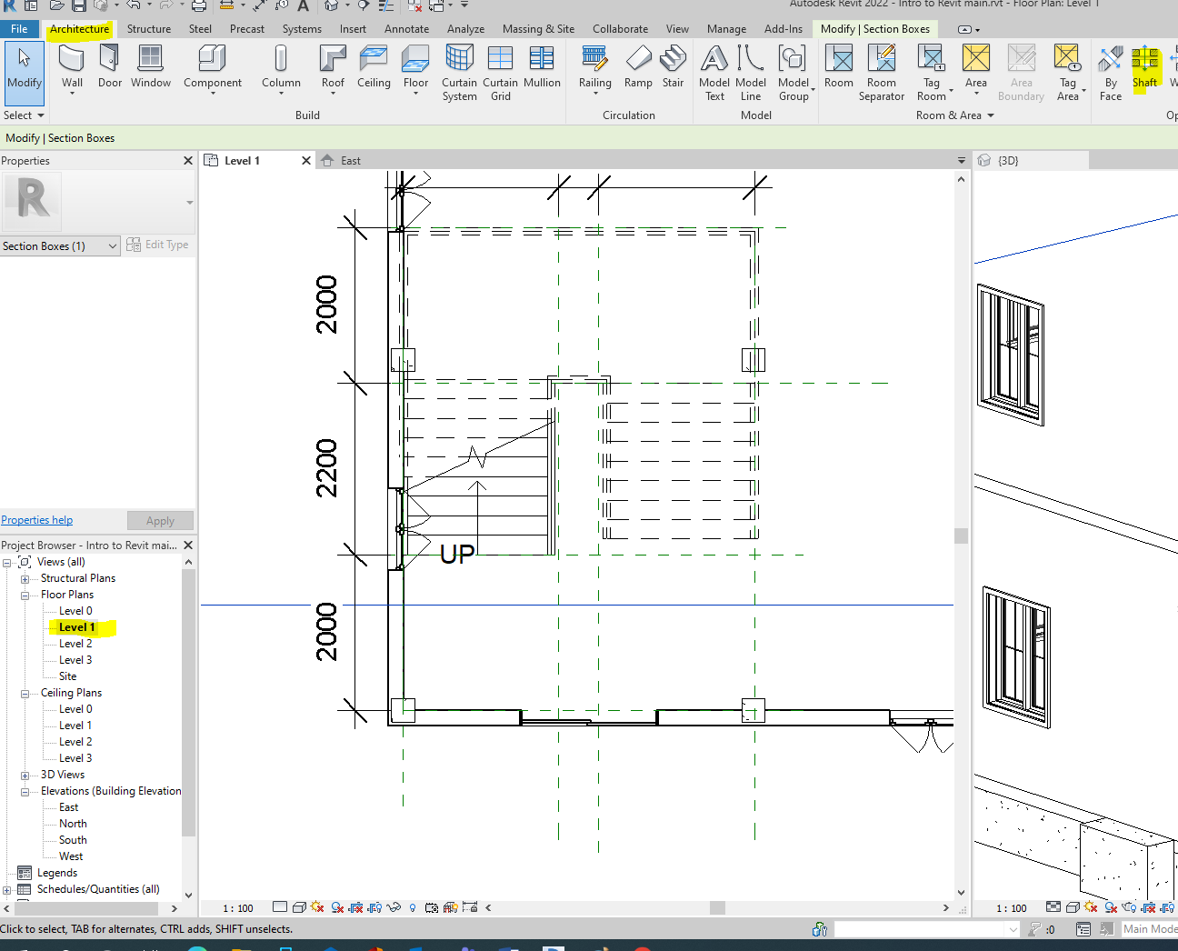
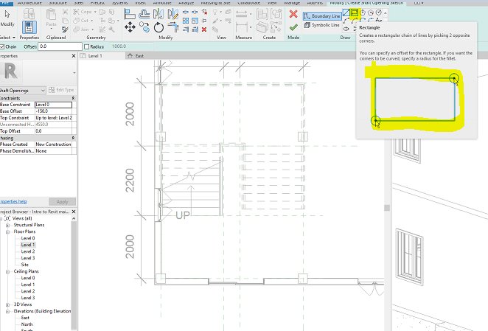

Use the reference plane as the guide to draw the shaft opening as below.

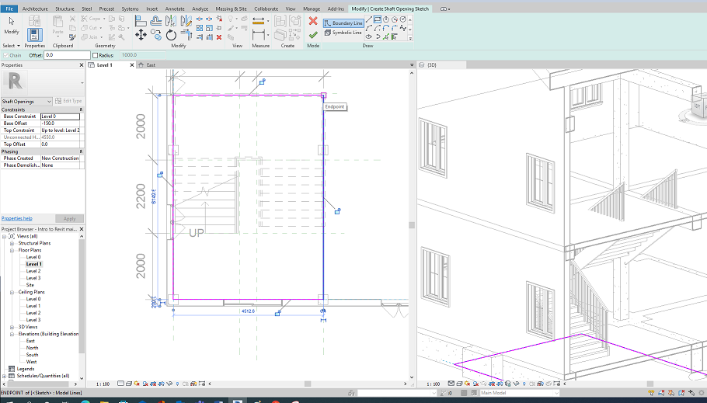
See the opening below.
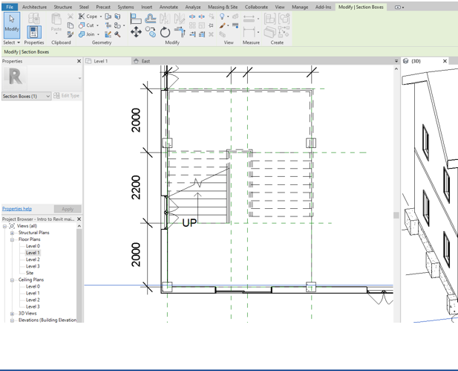

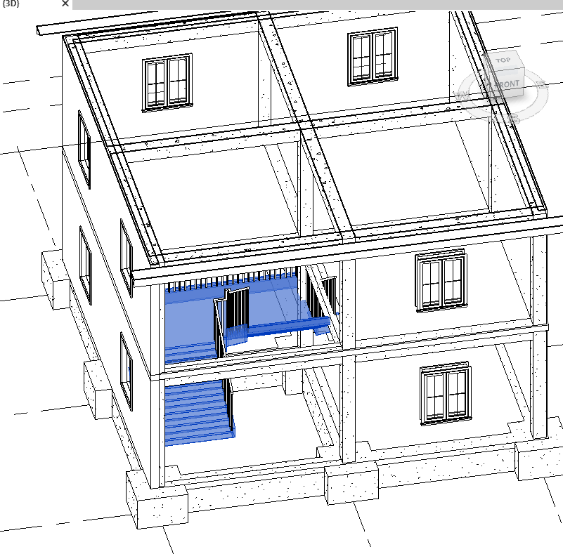

Editing shaft opening
Let’s edit the shaft opening and trace the stair profile to make part of the floor the landing.
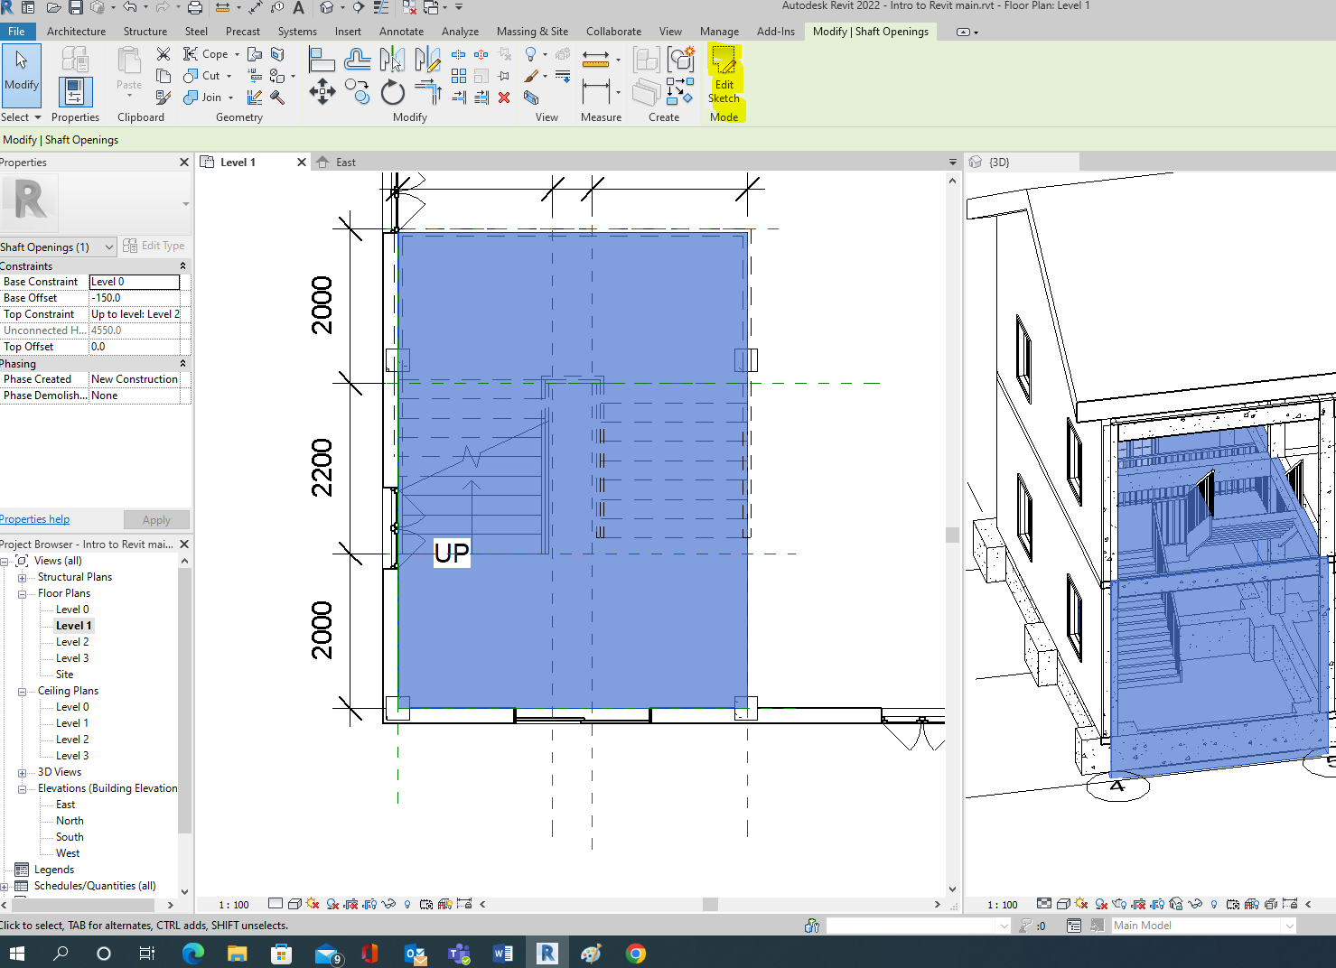
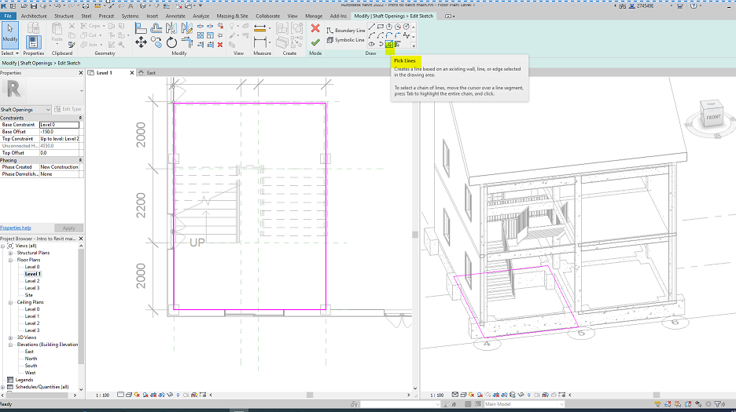
And using a pick line to determine boundaries as below.
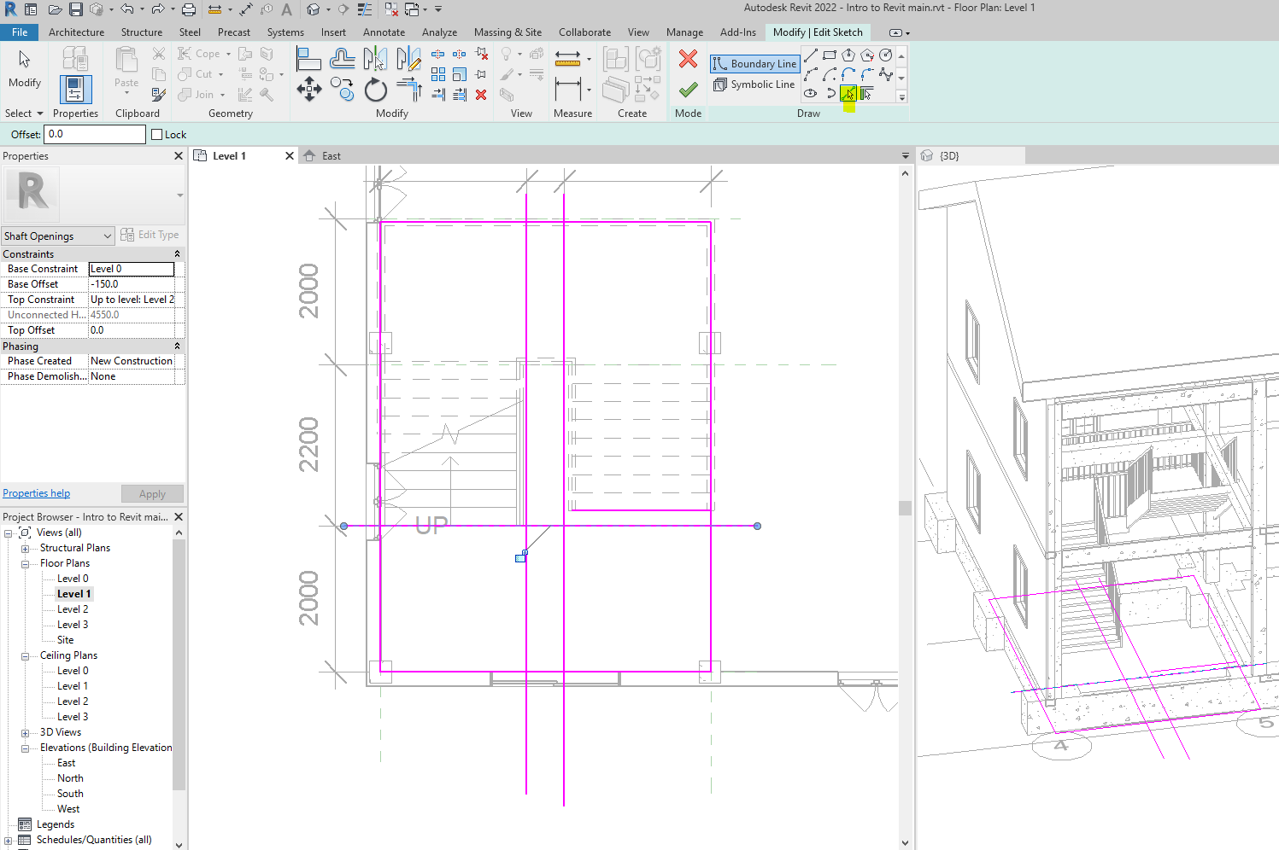

Trim the boundaries to make a loop for the staircase as below. (Tip: use the single trim command, click reference, and then the part to keep).
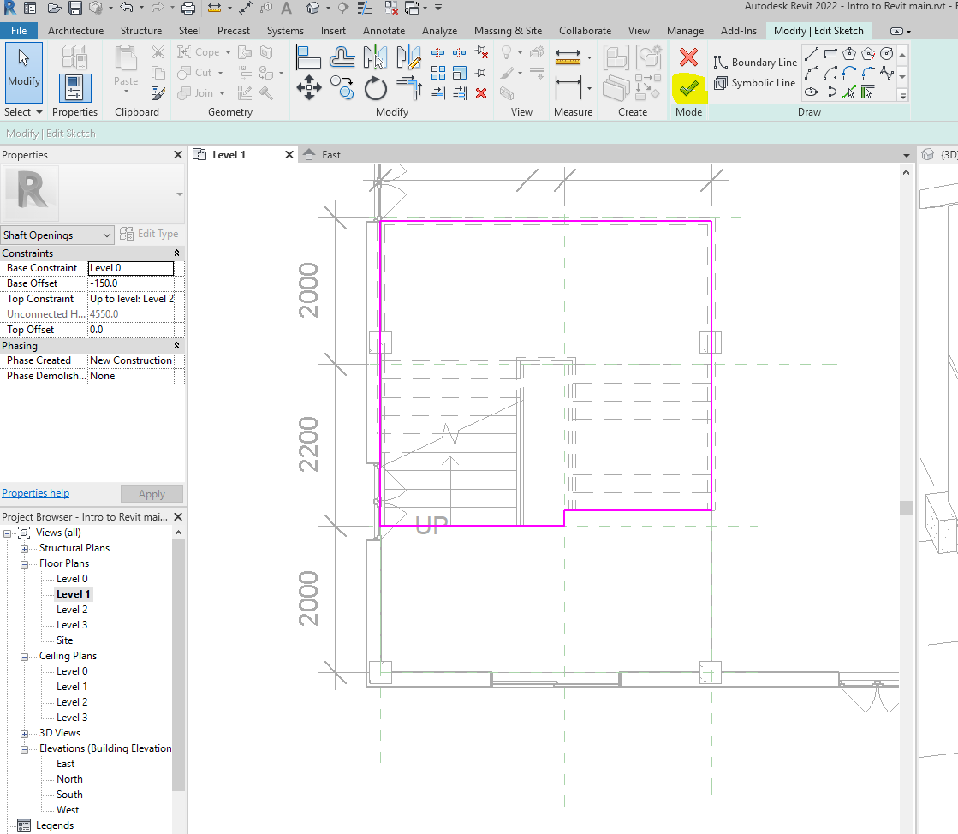

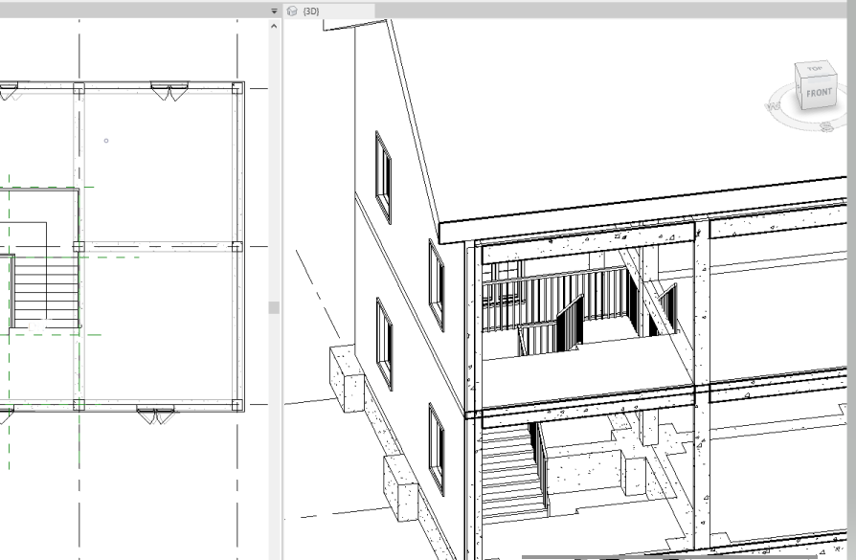

Adding components
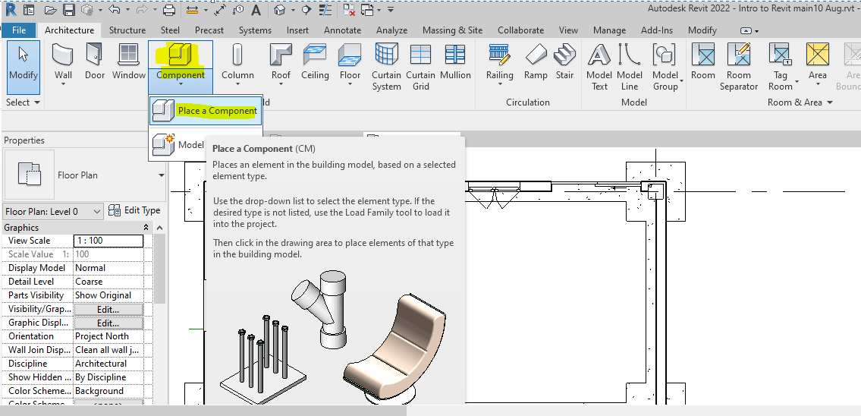
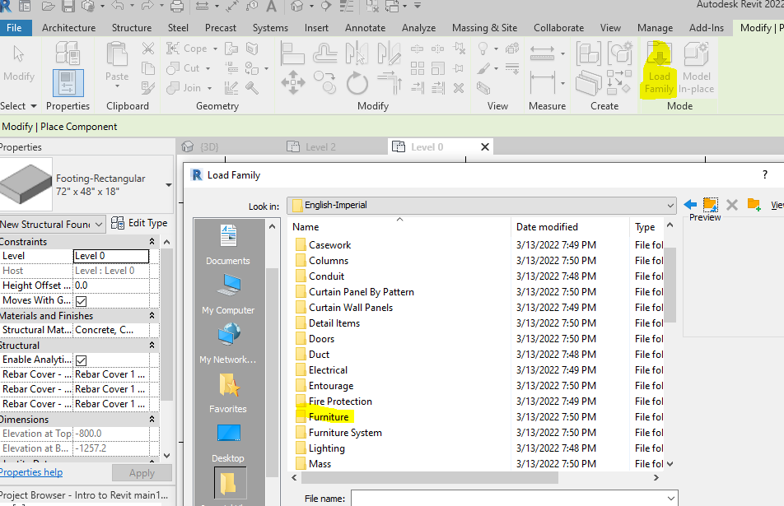
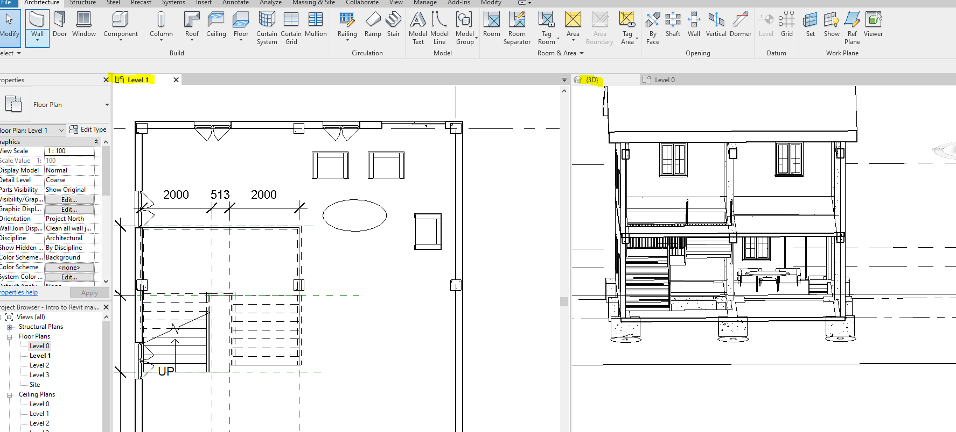

Generating an internal cam view
Select the camera tool, locate the camera, and adjust the viewing angle.

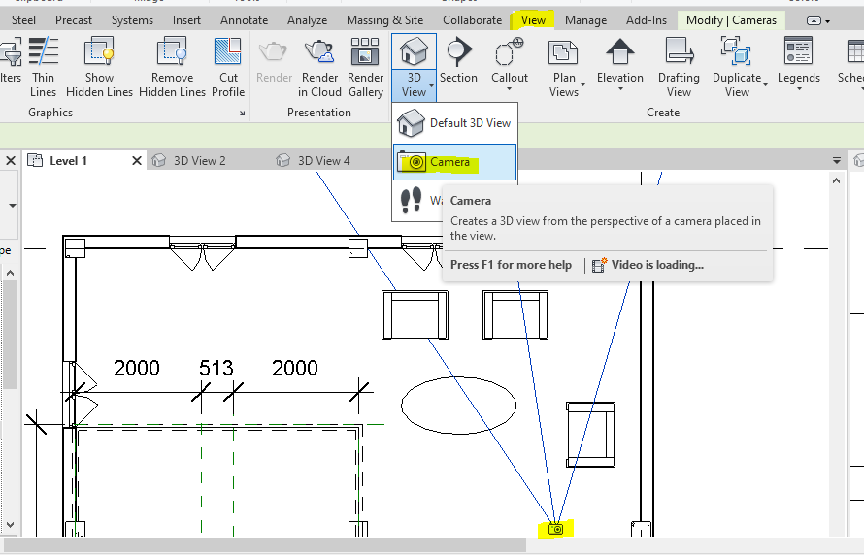
Now, see the 3D views created as a new sheet.
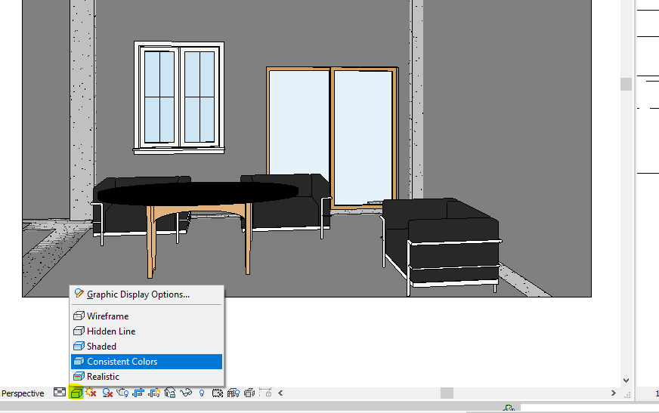

Adding annotations
Include complementary information (annotations) to the graphical info.

Dimension line
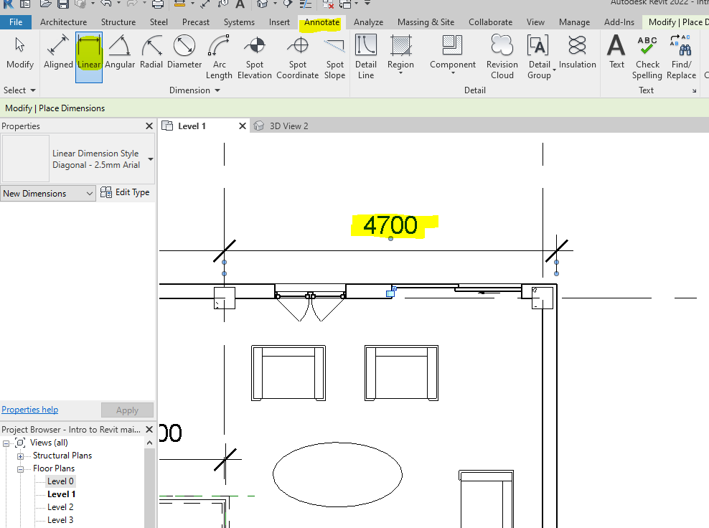

Room tag
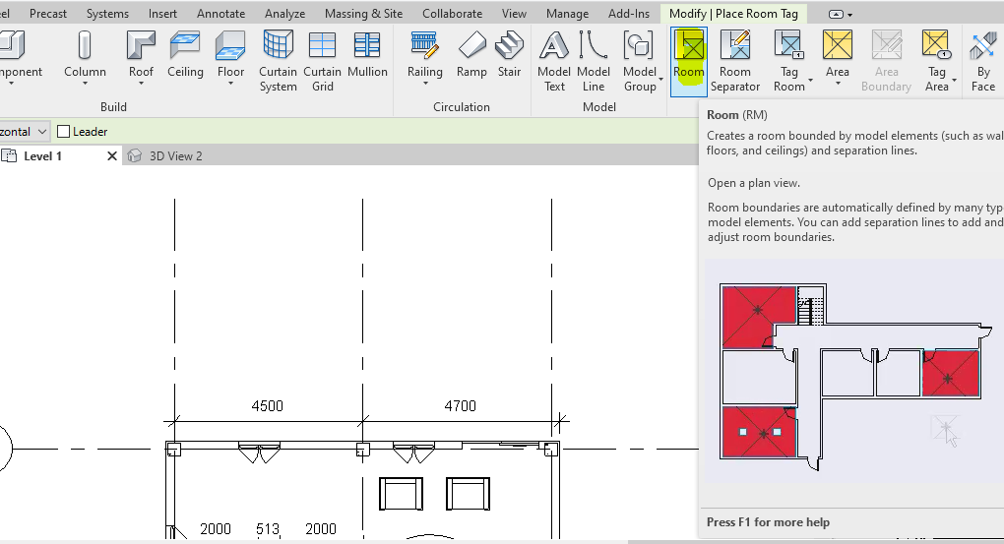
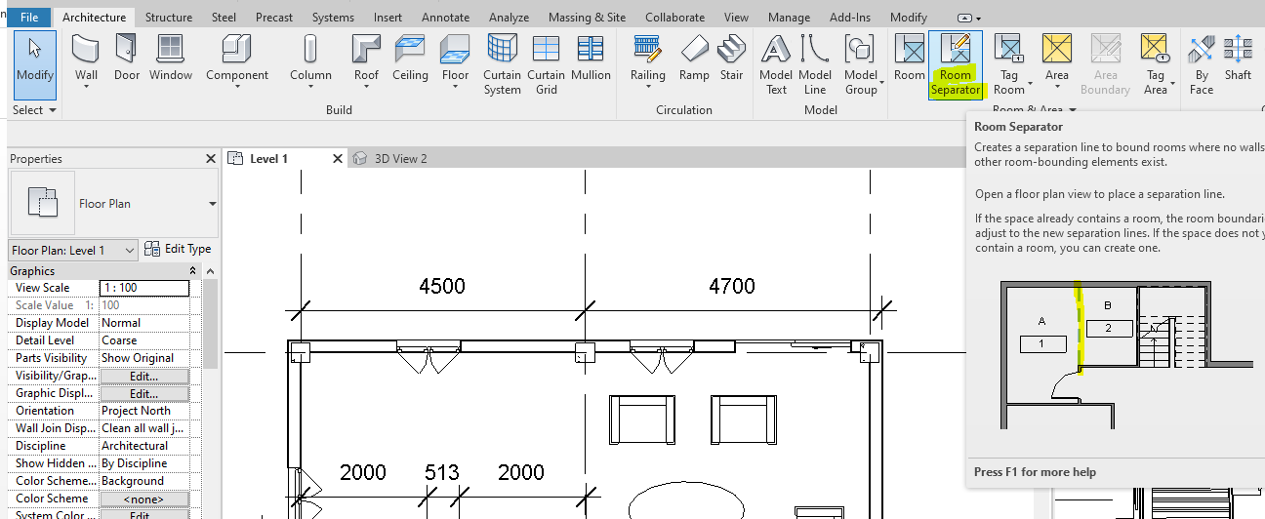
Now, add room tag as below.
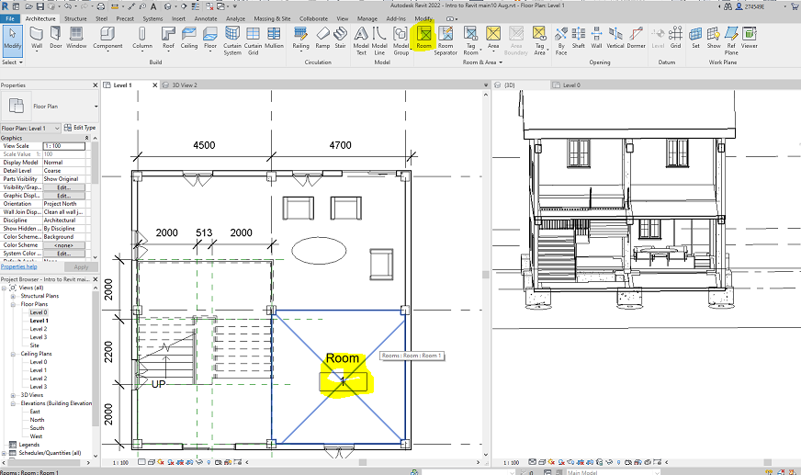
By hovering the mouse on the rectangular and double-clicking on them, you can edit them.
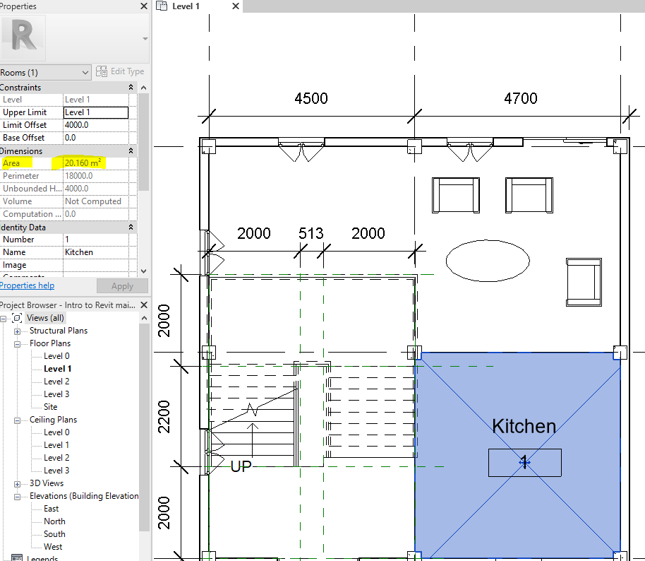 Also, color can be allocated to the area.
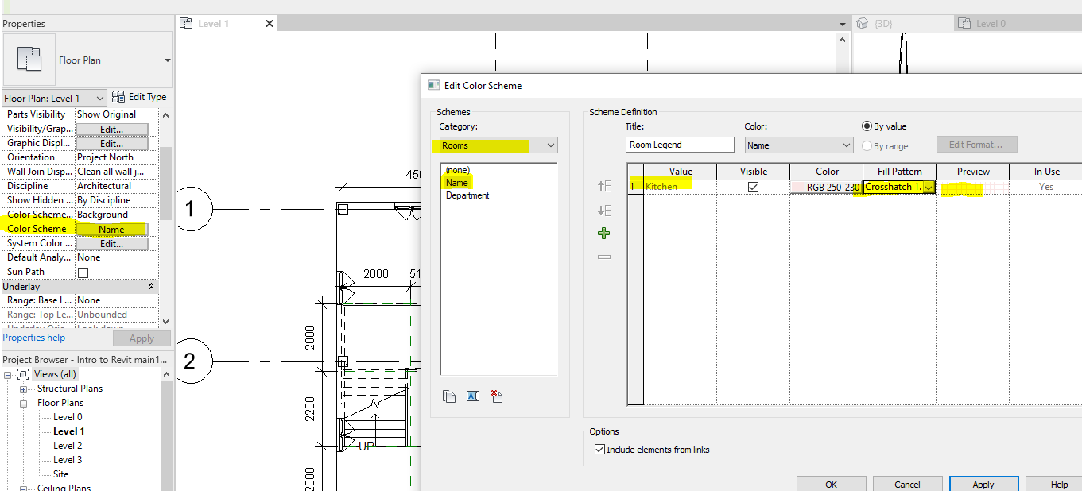
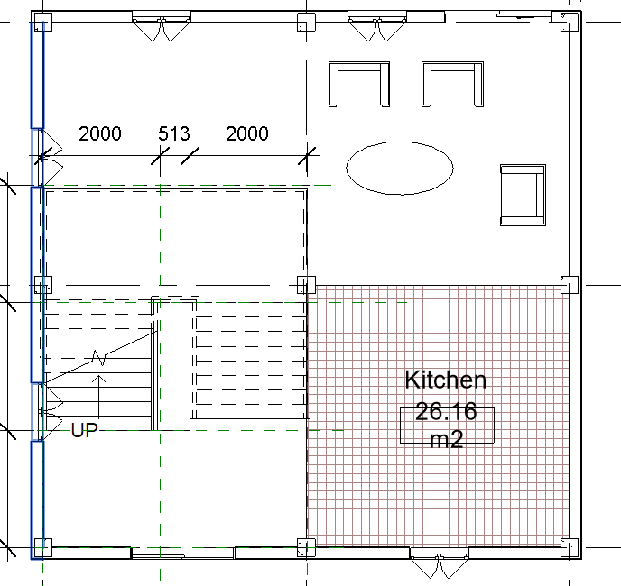

Creating drawing sheet

Enlarging information added
By changing the scale on the floor plans, the values can be enlarged. You can also turn on crop region to crop the view as below.
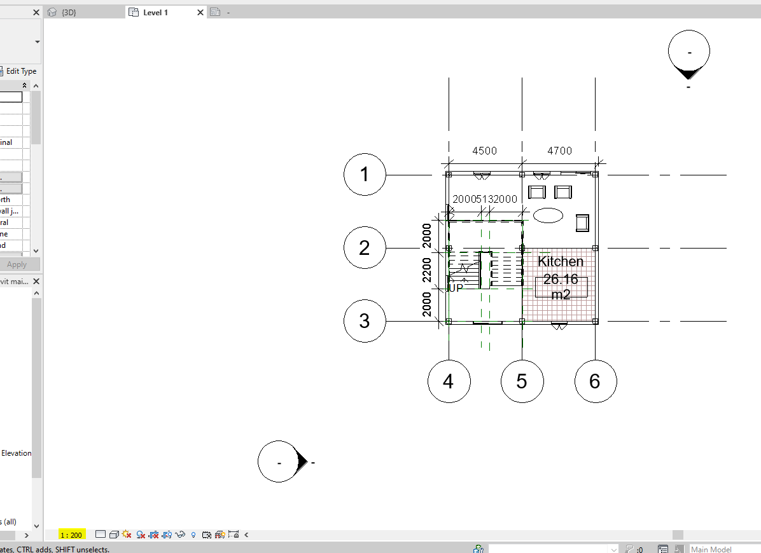

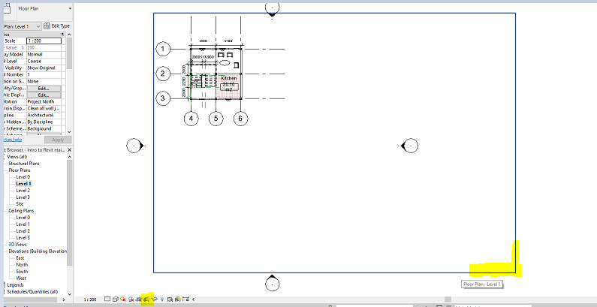
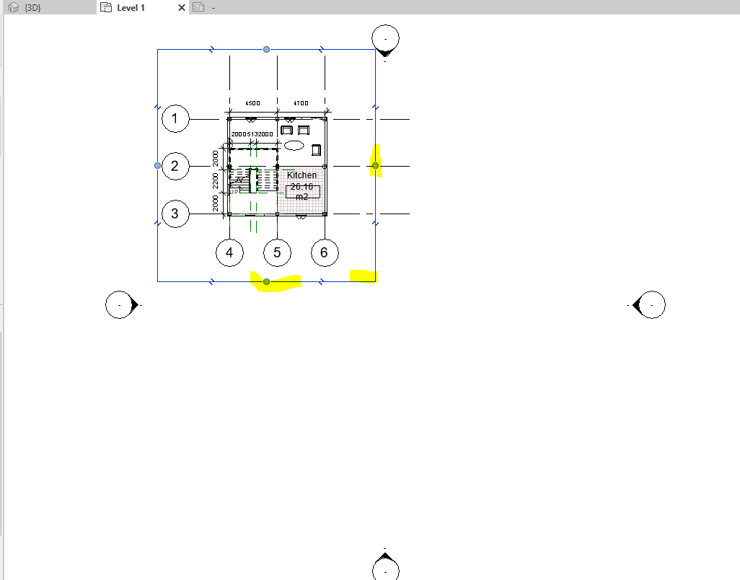
In the project browser, right-click on the sheet and make a new sheet. In the window that pops up (titleblocks selection), you can stay with the existing one or load a new one.
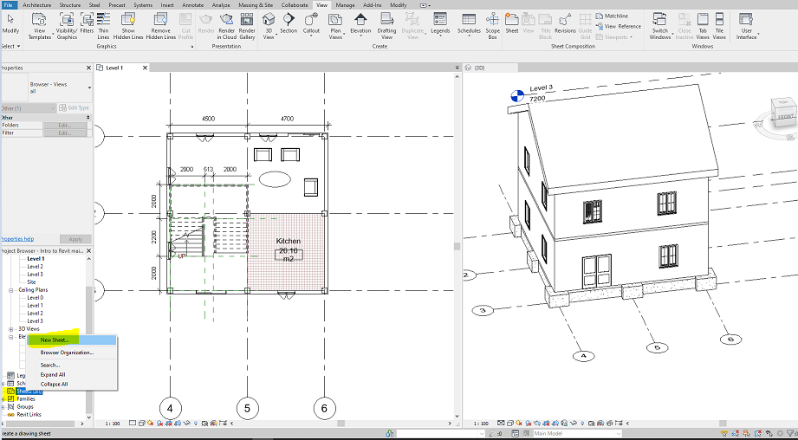

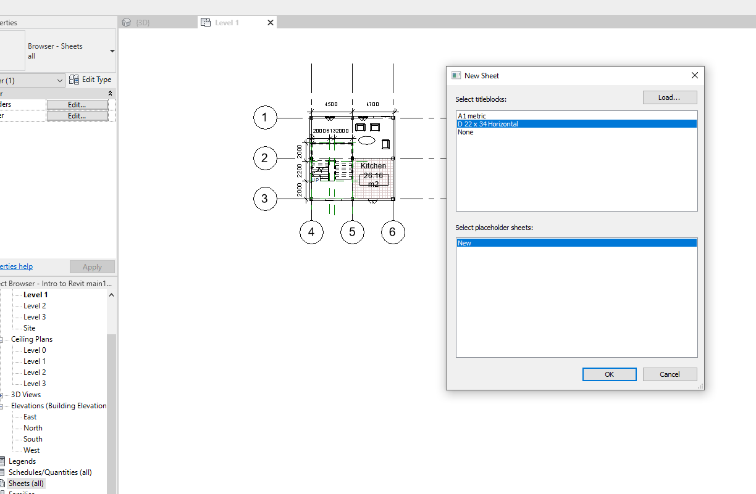
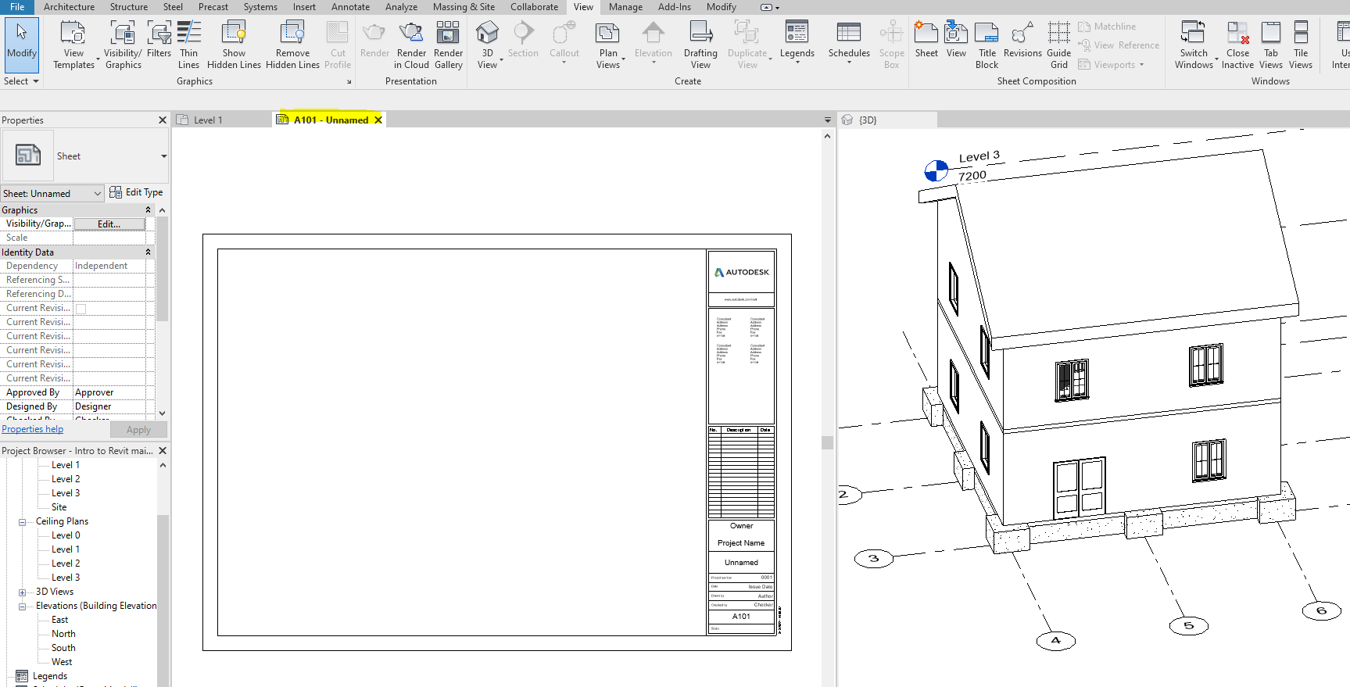
To enlarge the plan on the sheet, double click in the drawing and change the scale

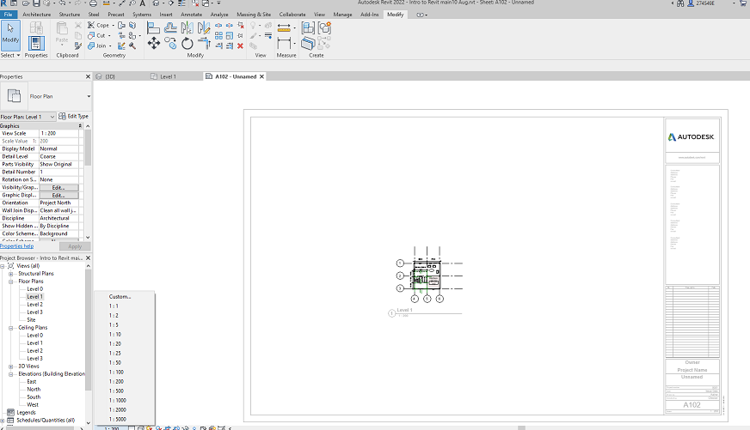

Hover the mouse on the boxes and click on them to name the sheet as Floor 1 plan.
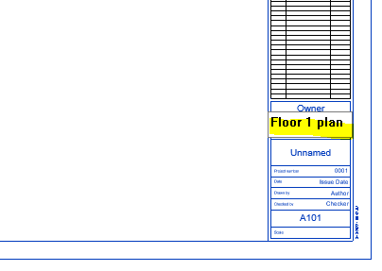

Part II: Creating Revit model based on AutoCAD drawing
This part informs you about the interoperability of AutoCAD and Revit software. Download the AutoCAD drawing of a 4 floors building given in the related week folder on the Moodle page. A Revit model should be developed based on the drawing by importing AutoCAD file to Revit (Linking AutoCAD files to Revit).

Importing an AutoCAD drawing to Revit

AutoCAD prerequisite for Revit

Unifying the units in both software applications

The AutoCAD drawings have been scaled in meters. Type UN in the command bar and set the unit as below.
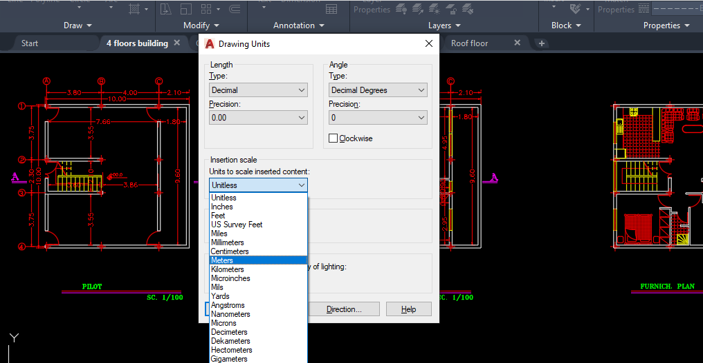

Separate the drawings
Each floor plan should be saved in a separate file. Check all the drawing units to be the same (in meters).
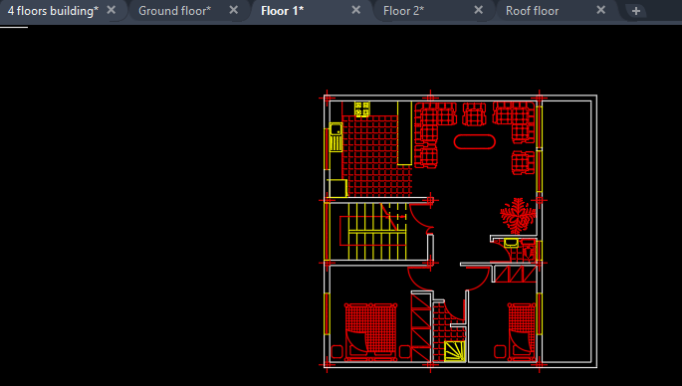

Coordinating drawings
Set up the drawings to the origin for coordinating the drawings in Revit (putting the drawings on top of each other in Revit).
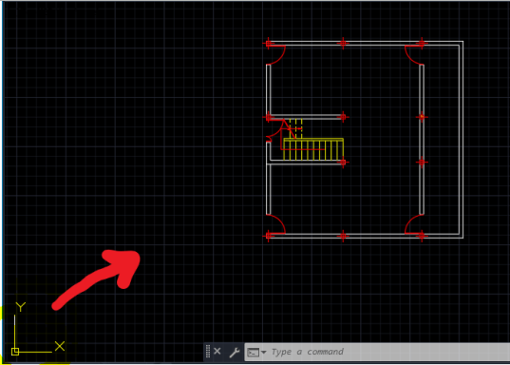

This action should be taken and saved for all the drawings.
To this end, select the same specific location of the drawings and set it to the origin. Select all the plan→ Move command→ select the location→ type 0, 0+ enter (the plan should be moved to the origin).

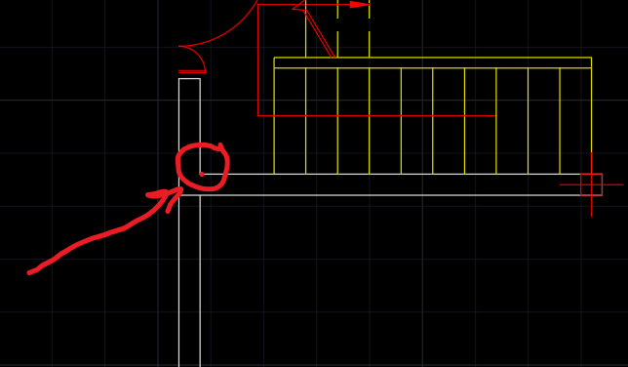
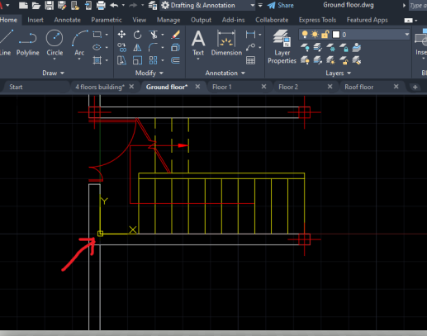

NOTICE. If the action is not completed, some adjustment should be done in the snap setting to move the plans to the origin (see below).
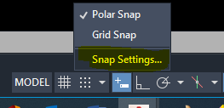
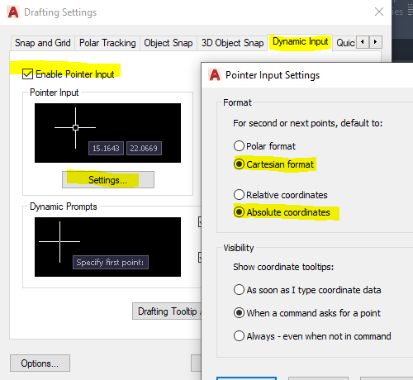
Now, follow the action under step 3.

Importing to Revit
Open up Revit and take the following steps.

Setting up Revit workspace
Unit adjustment using UN command.
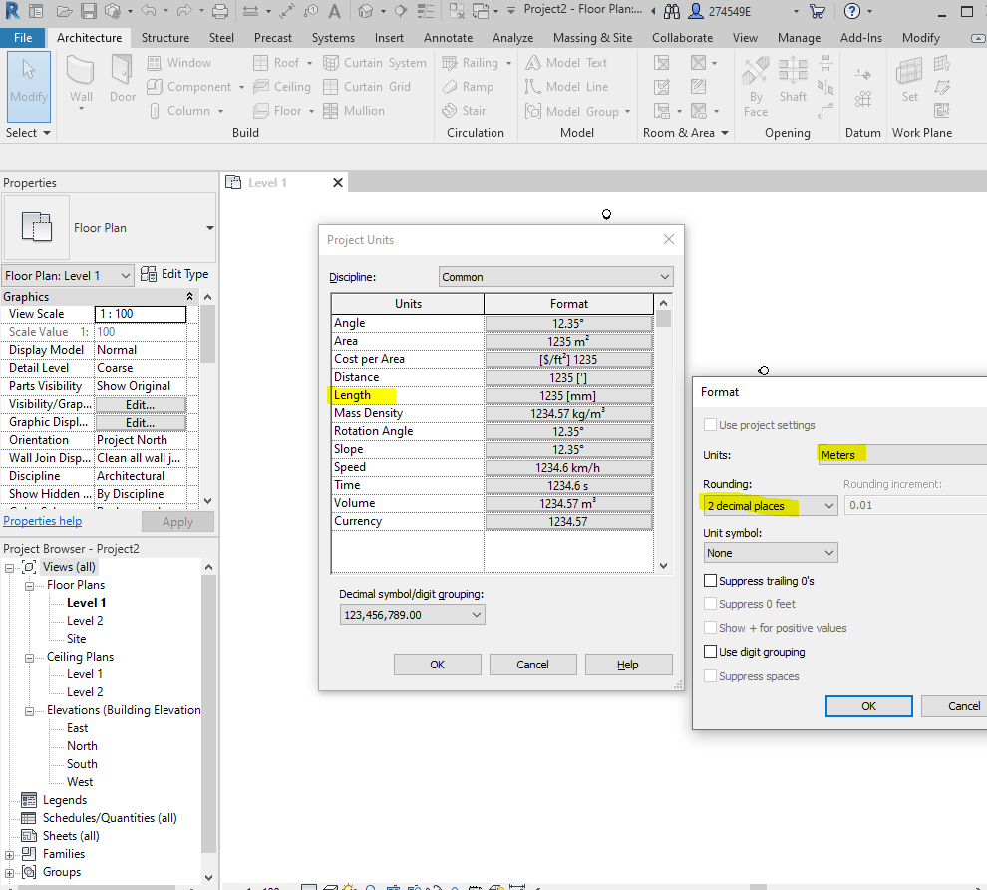

Adjusting or Creating levels
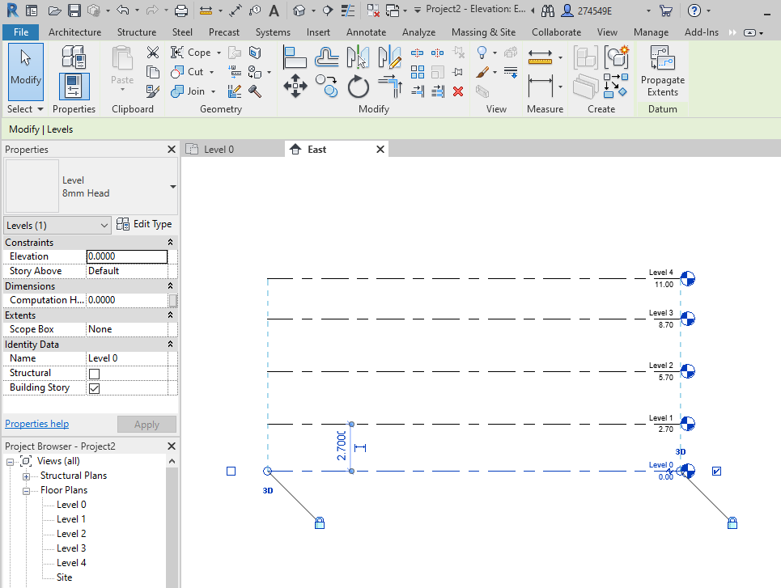

Importing AutoCAD files
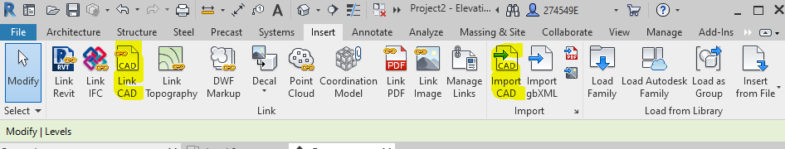
Insert→ Link CAD (NOTICE. Any changes via Revit would be reflected in the AutoCAD files and vice versa BY REFRESHING THE WORKSPACE.)

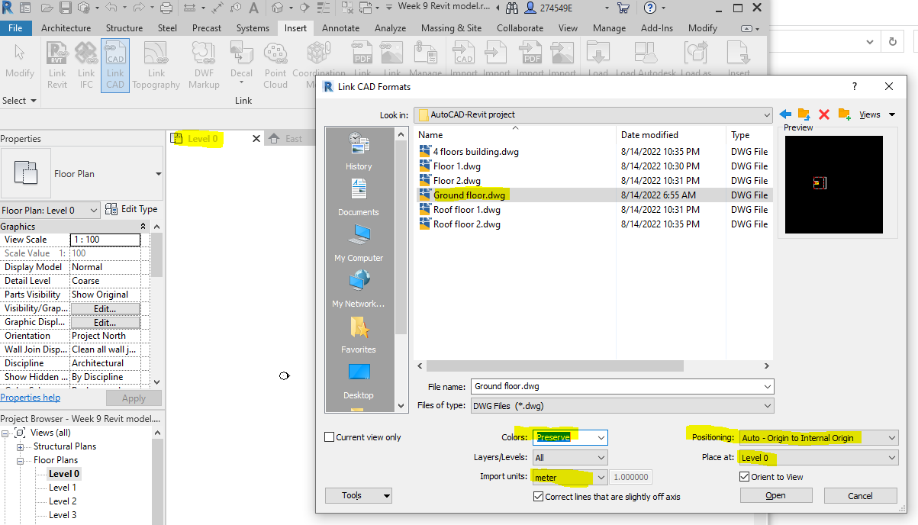

From observation, the plan is located at the origin. Compare the intersection location with the origin allocated to in the AutoCAD files.
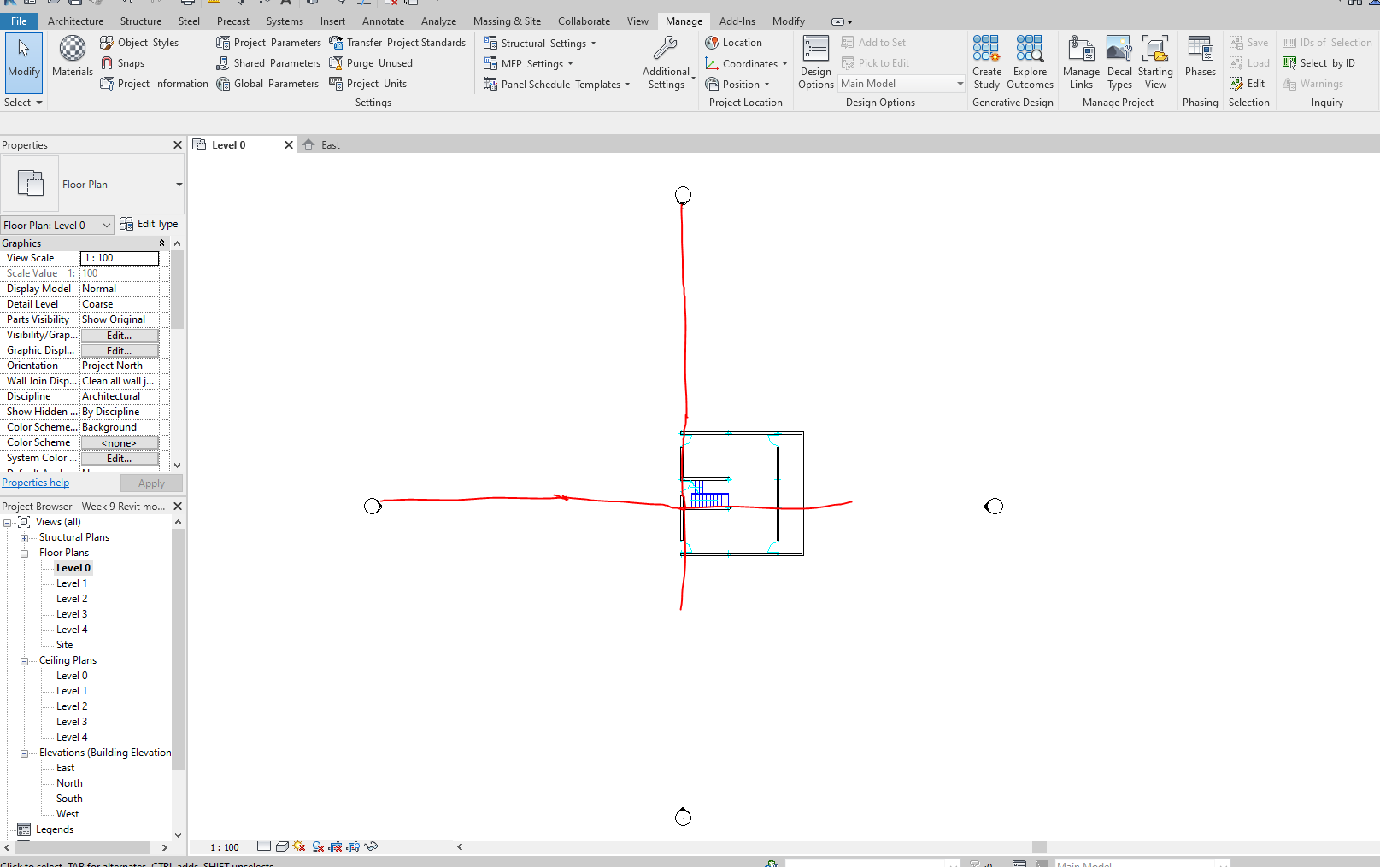

Repeat the process to link the other floor plans to Revit.
By observation, it can be inferred that the drawings are on top of each other.
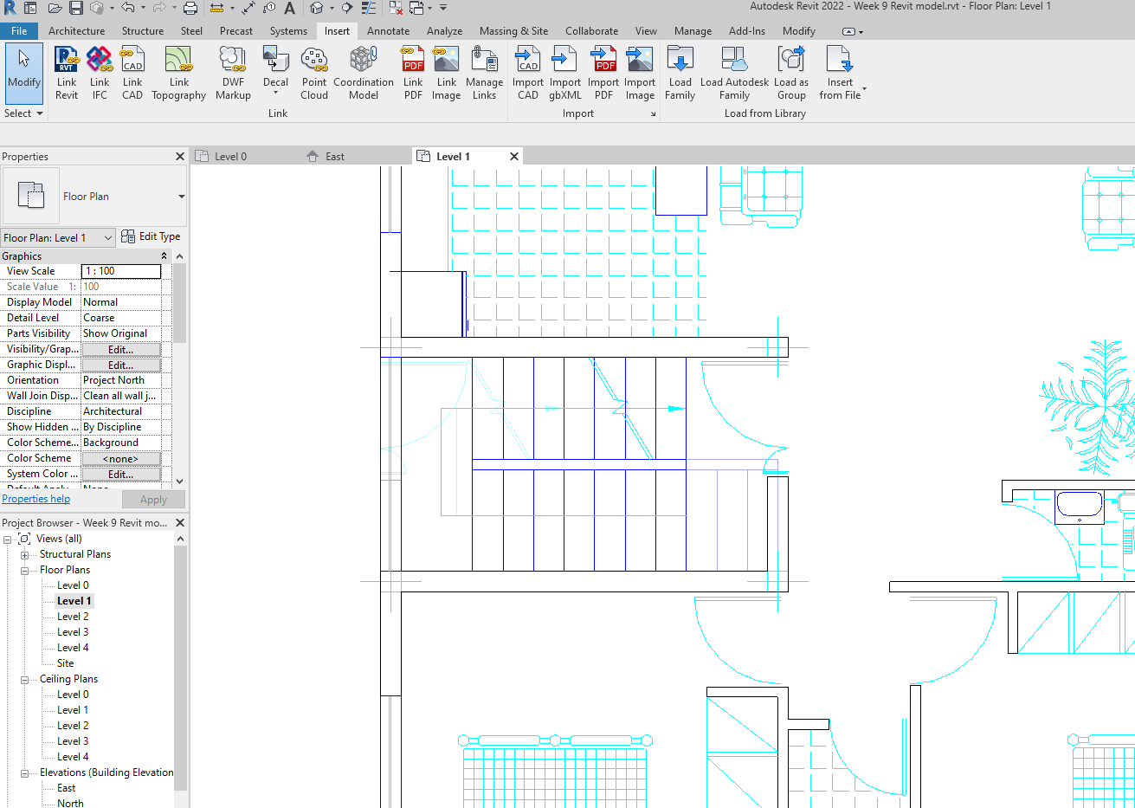

If a drawing has not been imported, properly, unpinned the drawing imported, then manually adjust it and pin it again.

Hiding the AutoCAD drawing of a lower level
To make the drawings hidden on the lower level, see below.
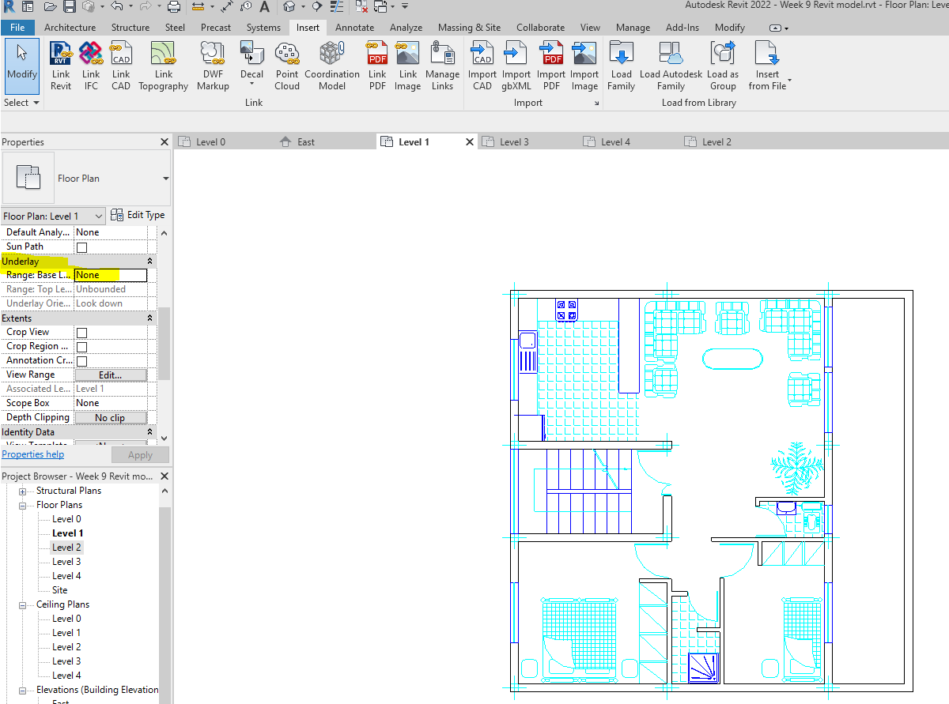

Drawing wall

Adjusting the transparency for a better vision of Revit elements
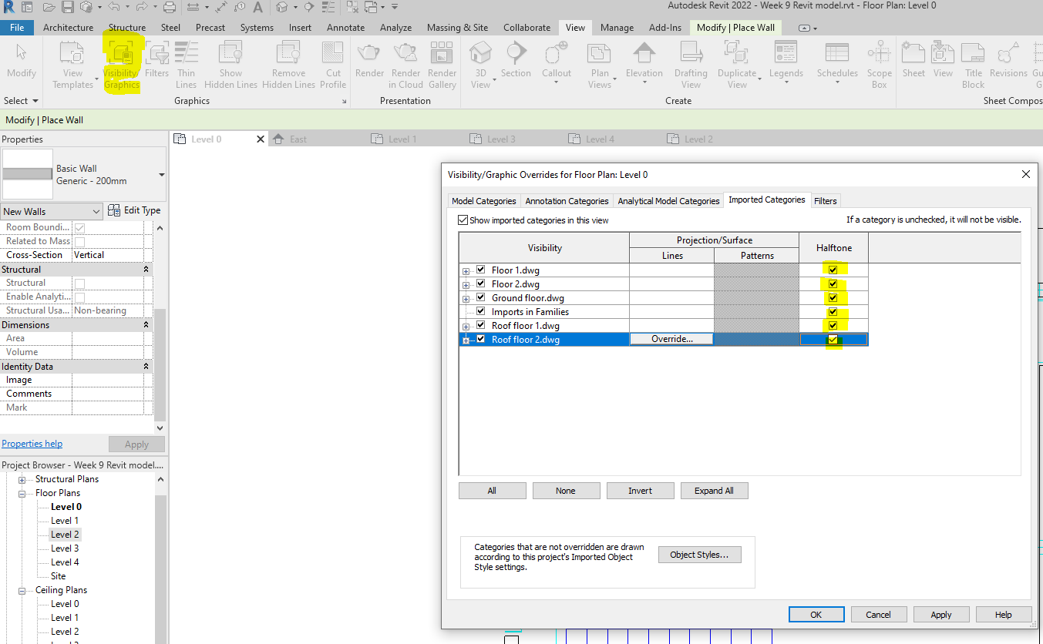

Use Wall command and pick the suitable wall tools. Let’s use Line and pick lines tools.
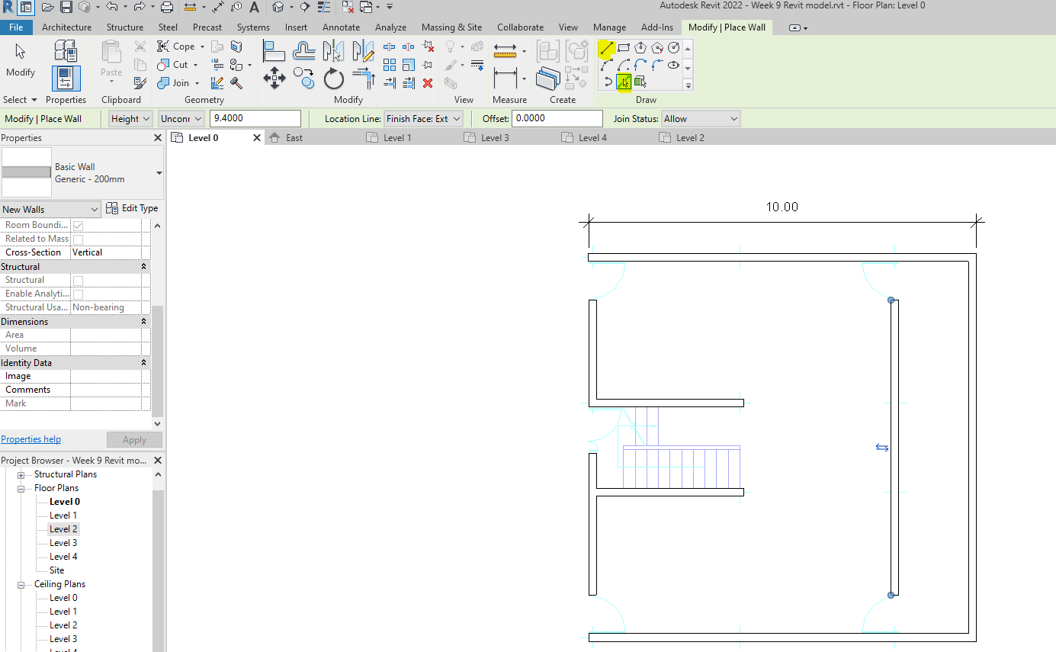
Using extend command to reach the required walls.
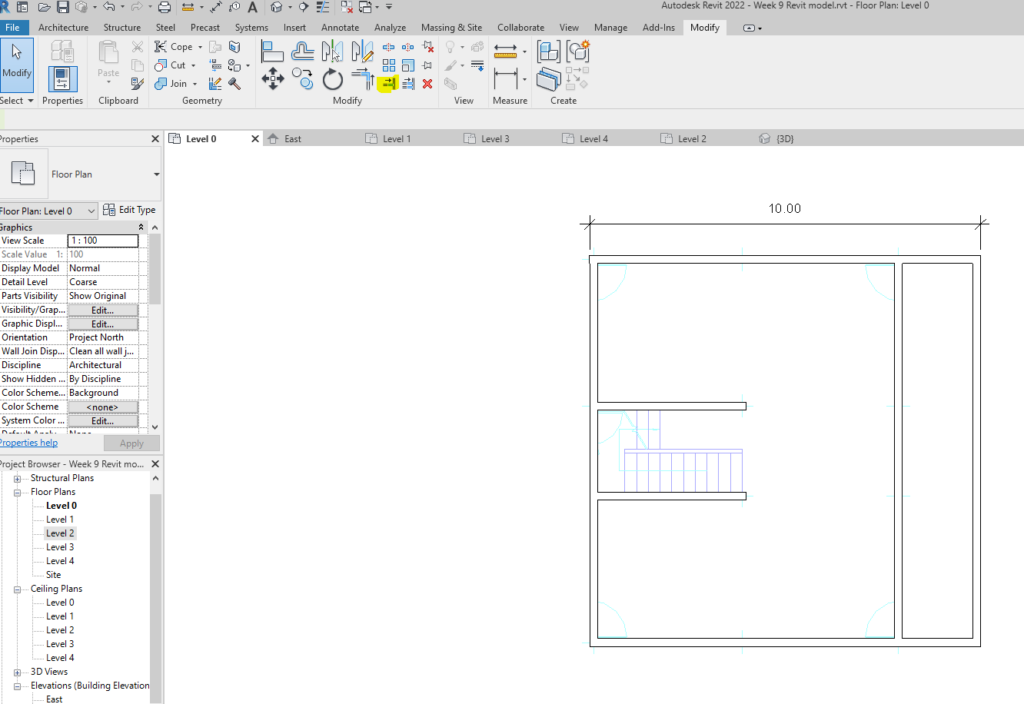
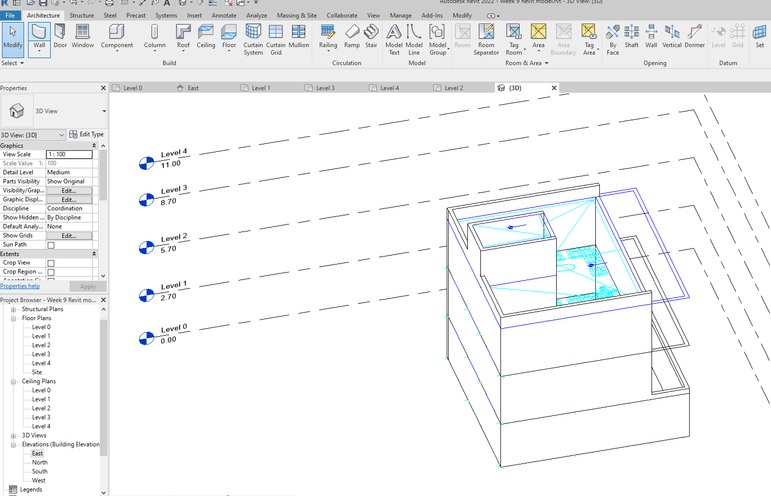

Creating a AutoCAD-based door in Revit
Use door command to create doors.
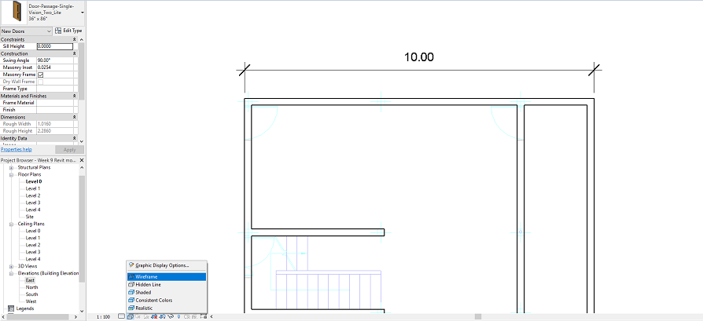
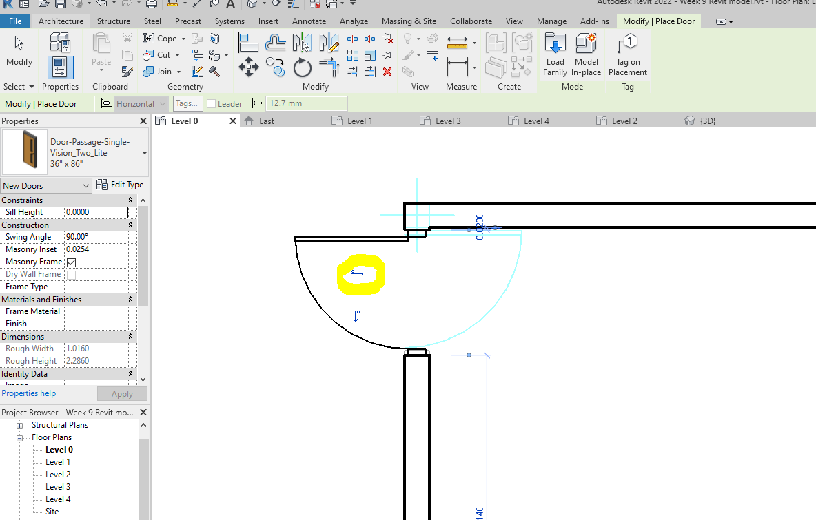

Complete the exercise by referring to the commands you have learnt before, and create windows, floors, stairs, and components according to the drawings linked. Also, add annotations where required.

End of the course

Thank you

