Project Brief – Sandridge Bridge

Activity  Sandridge Bridge  Steel Pedestrian Bridge | Location  Flinders Walk & Sandridge Bridge, Melbourne VIC 3000

Section A: Project Brief

Originally built in 1888 as a historic steel girder railway structure across the Yarra River, Sandridge Bridge was redeveloped into a dedicated pedestrian and cycle path.
You are a cadet design technician at Velocity Civil, engaged by a local council to design a steel pedestrian bridge across a creek in a suburban park. The project involves environmental sensitivity, heritage overlays, and accessibility compliance.
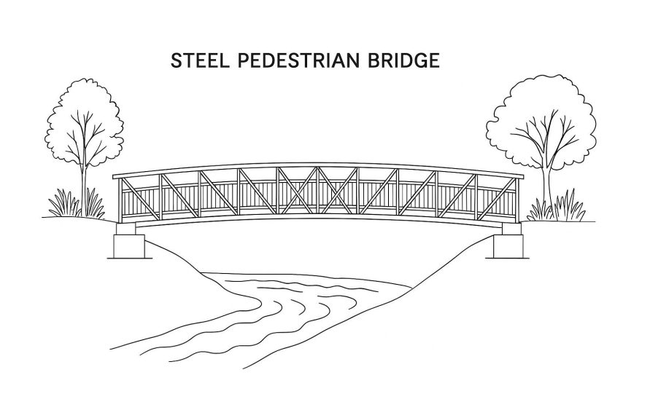

Section B: Objective
Propose the required section area of main beams of a single-span steel pedestrian bridge (12m span, 2.5m width) with anti-slip decking, and balustrades. The structure must meet relevant Australian Standards and withstand pedestrian and cyclist loads. Consider the beam as a straight profile.

Section C: Activities

Complete the activities using the Velocity Civil project templates.
- Plan the design, develop a project schedule, identify risks, and allocate resources.
- Structural designer asked you to contribute to carry out structural analysis (loads, moments, stresses), compare two design options, and draft drawings using manual detailed sketch or AutoCAD. The designer has requested that you propose the required section area based on the bending moment applied to the main beams.
- Finalise the design with cost estimation and stakeholder input.
- Provide on-site design advice and validate implementation with updates where needed.

Section D: Appendix

